YouTube – The Basics
IST Streaming Video Session – 30 March 2012

Step 1 – You will need to create a YouTube account. This includes a user name, password and some personal details. Once complete, you will be directed to the home page that looks like this. You know when you are logged on as your user name will appear in the top right corner
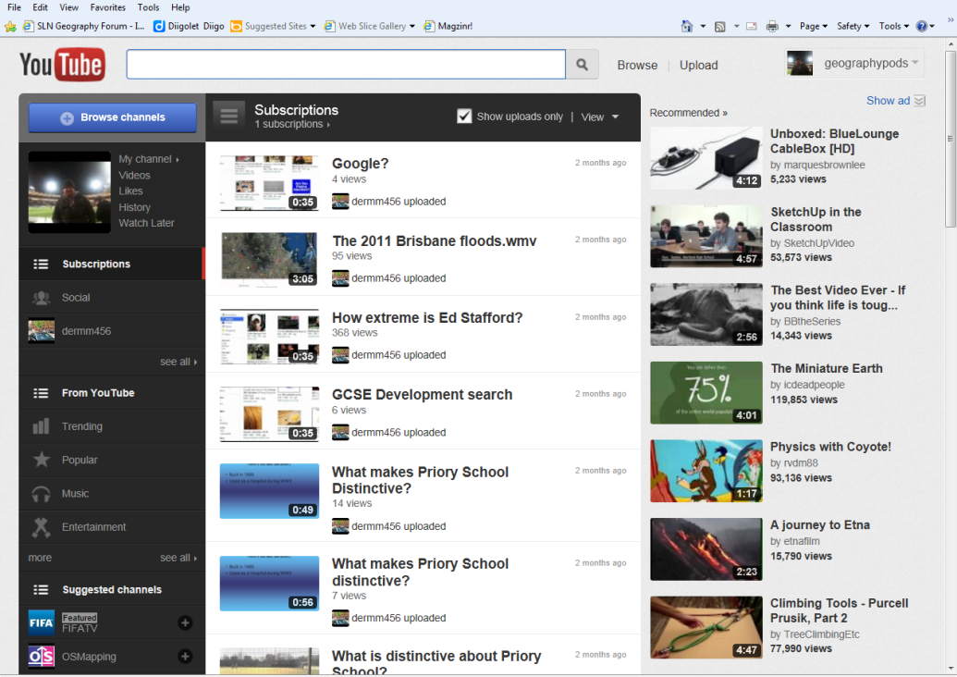

Step 2 – To upload your first video, click on the down arrow just next to your user name. A menu will appear beneath and you should click on Video Manager. A list of videos currently uploaded by you will appear (although you have none so far)
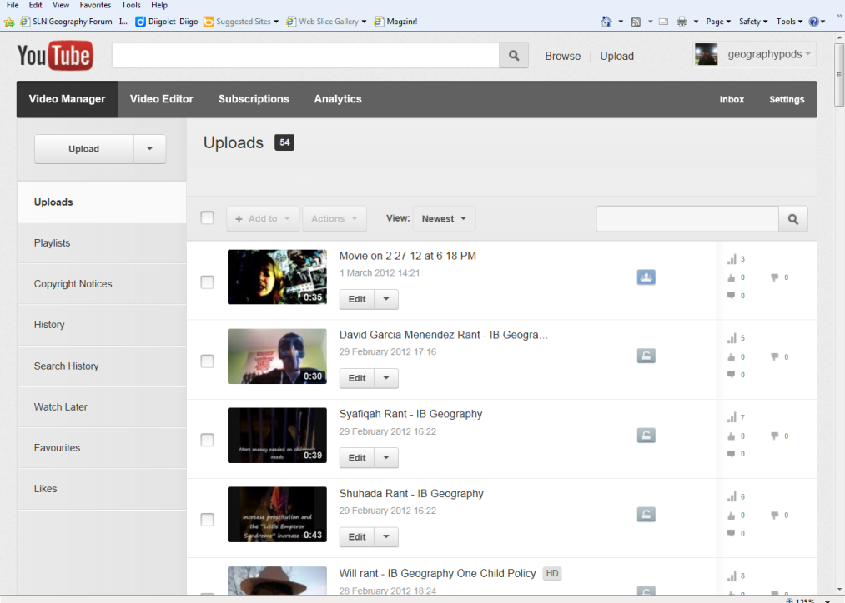
Step 3 – Click on the upload button here and you will be taken to a menu where you can choose a video to be uploaded to YouTube. Don’t forget about the copyright rules and YouTube now has an automated monitoring service.
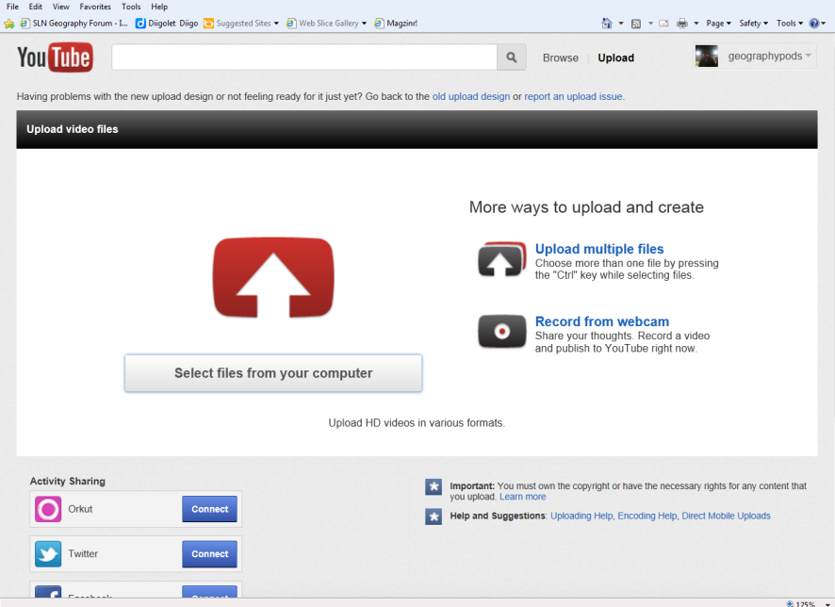
Step 4 – A screen will appear that asks you to select suitable files from your computer. Click on this button and you will be taken automatically to your My Videos folder to choose a video for upload. You may upload any videos up to 10 minutes long. For longer videos, you will need to sign up for a ‘Pro Account’.

The uploading – Explanation of Security and Tagging
Step 5 – There is quite a lot to do on this page as the video is uploading to the YouTube account. Follow the steps below to help you out on your first successful upload!
Choose your level of privacy here. Check your school policy with regards to publishing images of children and parental permissions
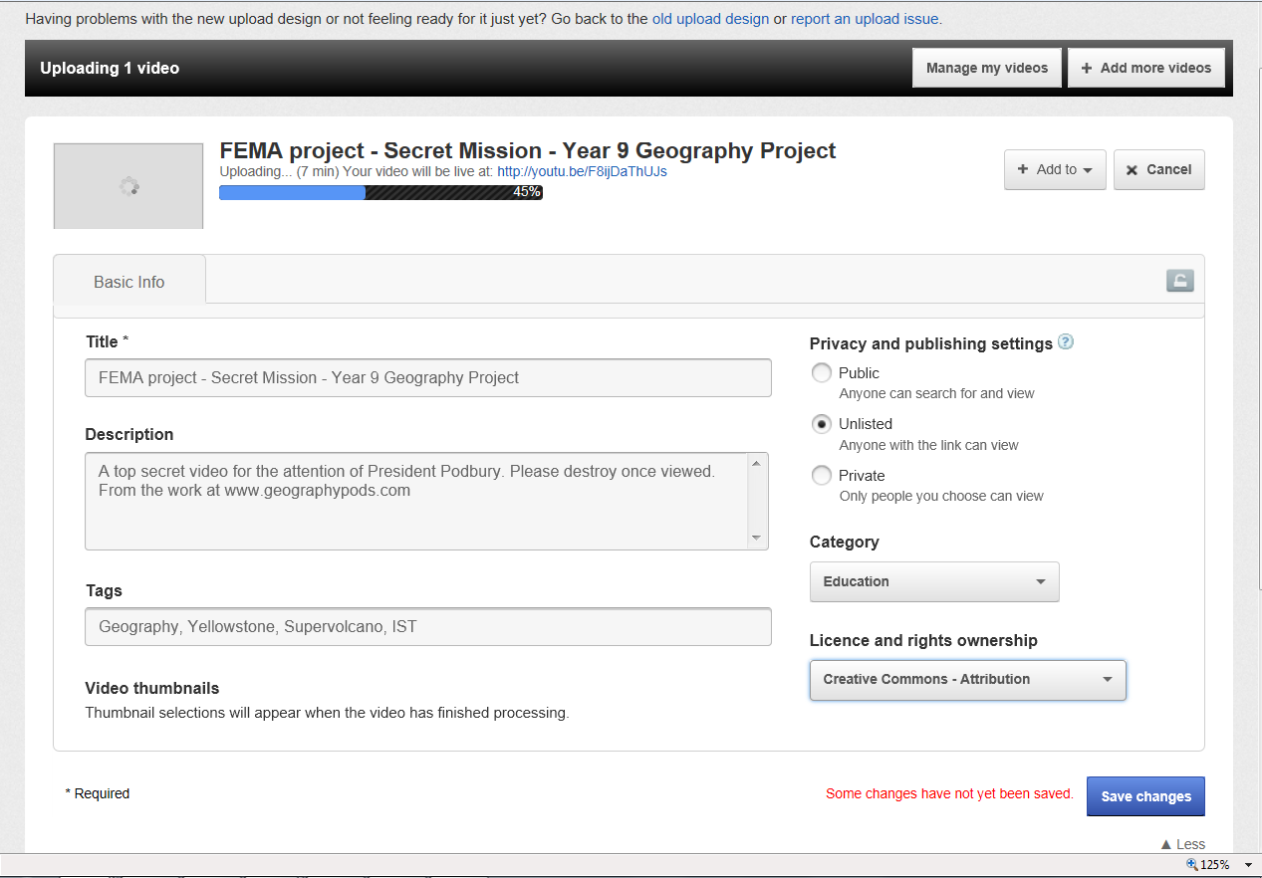

Insert the title of the video here

Choose category here – e.g Education
A description of the video here

Choose the rights ownership.
Insert tags here. This will enable people to search for your video should you make it public

And finally save the changes and wait for your video to upload.

Step 6 – Return to the Video Manager section of your account and your video will appear after a short time. Click the play button to make sure it works.
Now you have started on the road to having your own YouTube channel. We need to work out the easiest way to edit videos and embed into common applications such as PowerPoint.
Embedding YouTube videos into PowerPoint 2010. This follows the same structure as the information on www.geographypods.com and file sizes are minimised by simply having the video broadcast through the PowerPoint rather than the whole video taking up large amounts of space on your VLE, website or school computer.
Step 7 – Download the sample blank PowerPoint from the www.geographypods.com site and follow the instructions set out to embed a video (of your choice) into this presentation.
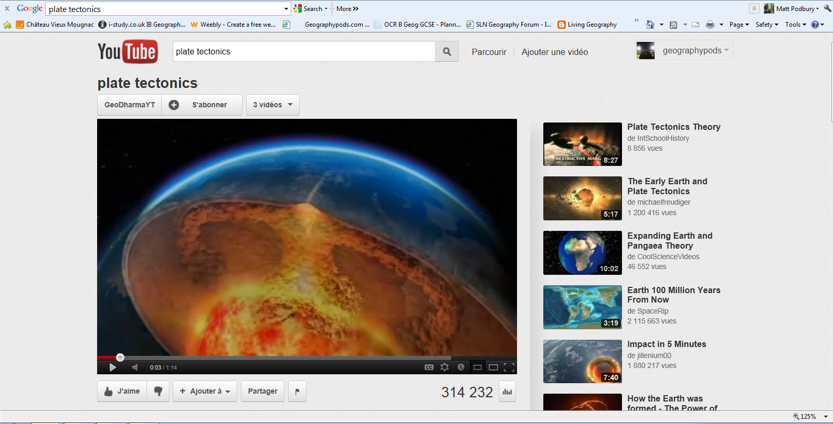
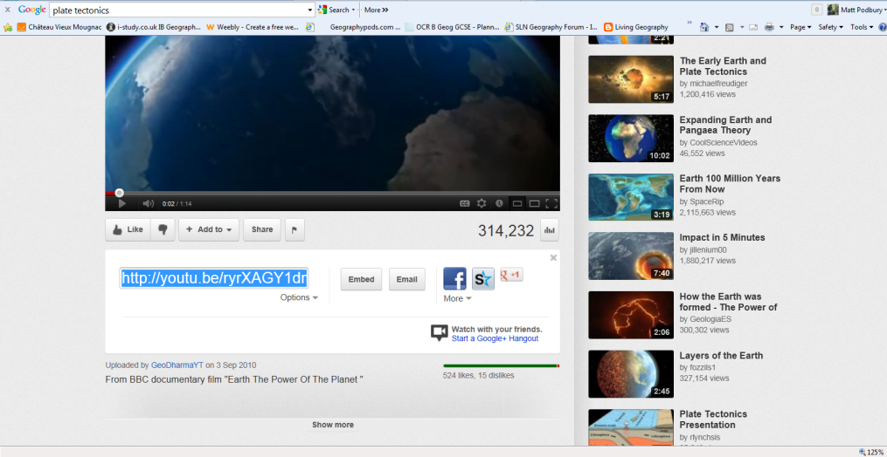
Search for a suitable short video that you would like to embed. This could perhaps be used as part of your lesson for example as a starter or recap at the end of the lesson. Just underneath the video, you will the ‘Share’ button. Click on this and the menu will expand down beneath.

Step 8 – You now need to click on the Embed button. This will open up a complex html code beneath.
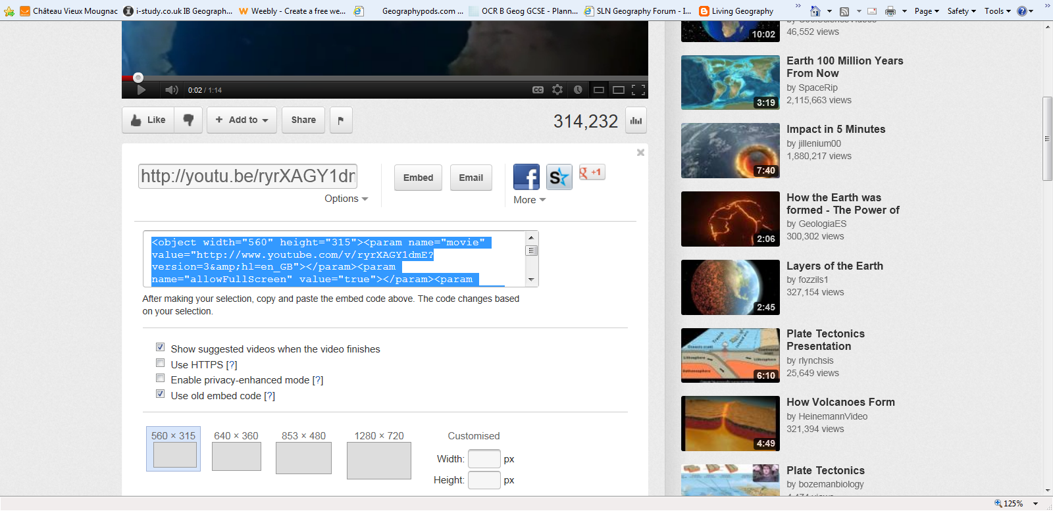

No read to read or understand this code but you do need to tick the box below entitled ‘Use old embed code’ as well as keeping the top box ticked. Then ensure that the code is highlighted before copying it (CTRL + C).
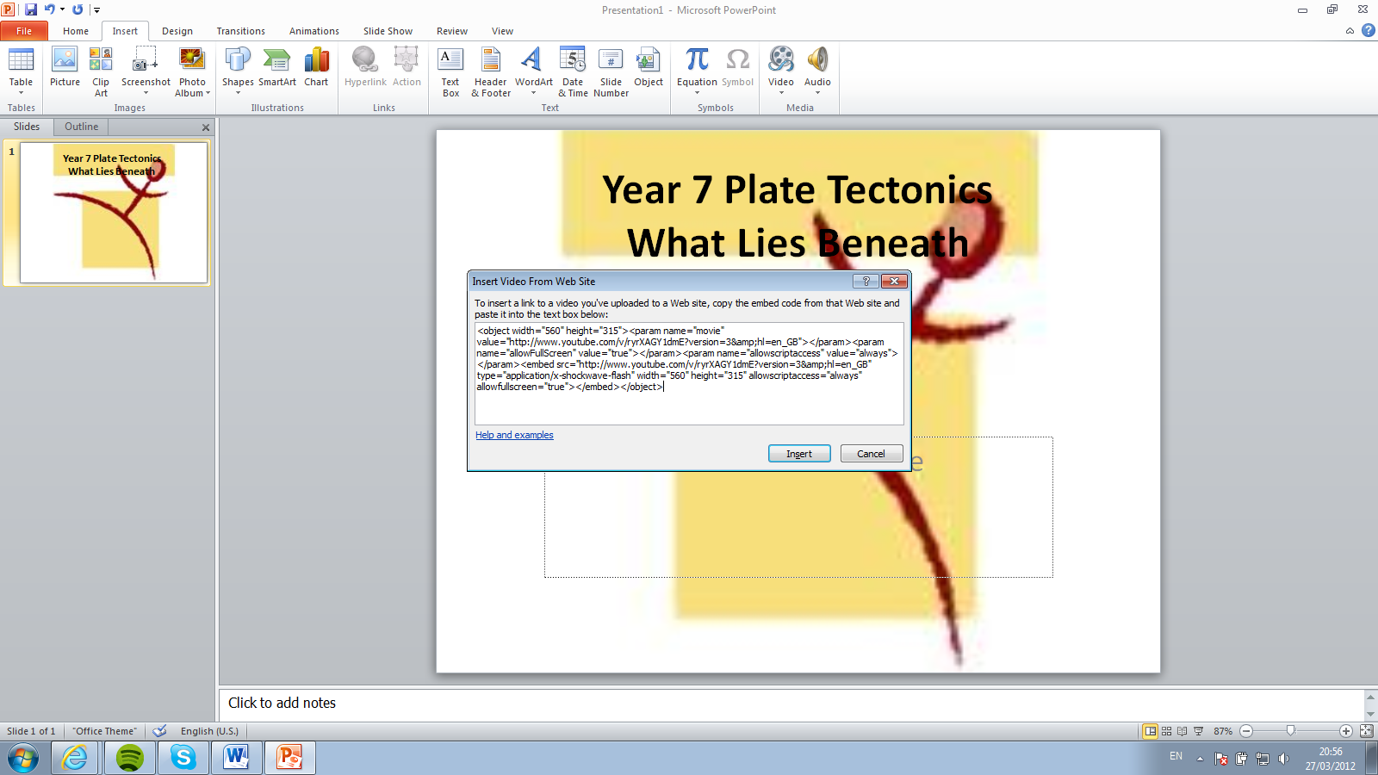
Step 9 – Open your PowerPoint presentation (2010). Click on the ‘Insert’ tab on the top menu and choose the down arrow next to ‘Video’. On the small drop down menu, click on ‘Video from Website’.

Paste the HTML code into this box and then click on ‘Insert’.
Step 10 – Your video should then appear on your PowerPoint slide. Drag and resize the video to suit your needs. On the top menu, click on ‘Slideshow’ and then choose ‘From Current Slide’. The slide should then appear and if you press play, the YouTube video should start to play.
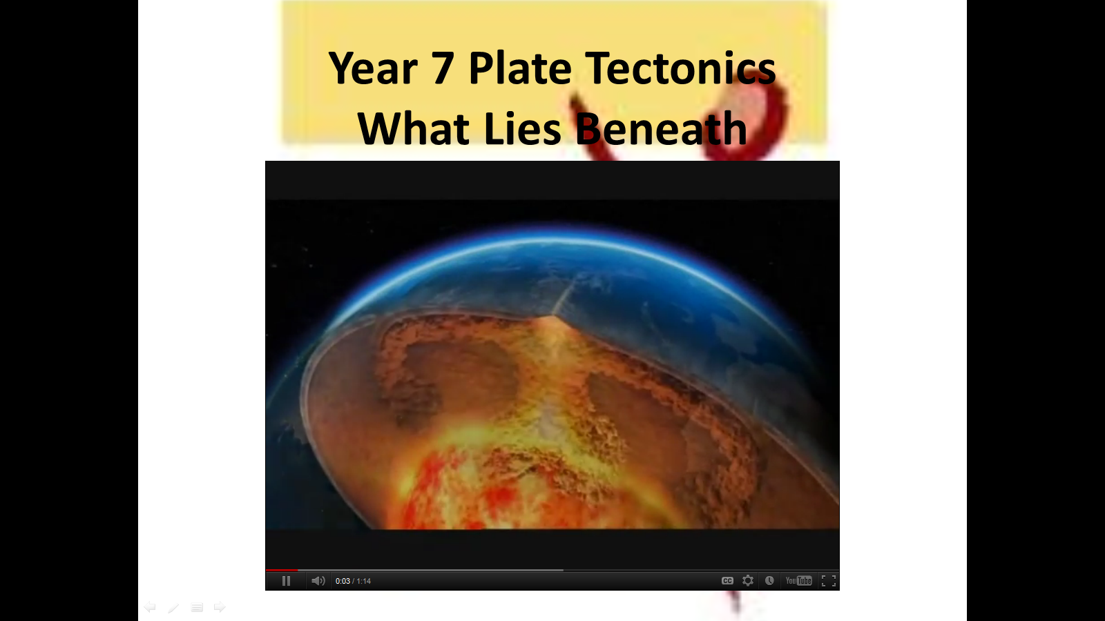

Step 11 – Video in this format perhaps does not look the best and so you could use a few simple techniques to improve the quality of the presentation. Right hand click on the YouTube video on the first slide of the PowerPoint and copy. Navigate to slide 2 and past the video onto the television. Re-size the video to fit the screen and check to see if it works by following the same instructions in step 10. You can add multiple videos to each presentation if needed by following the instructions above.
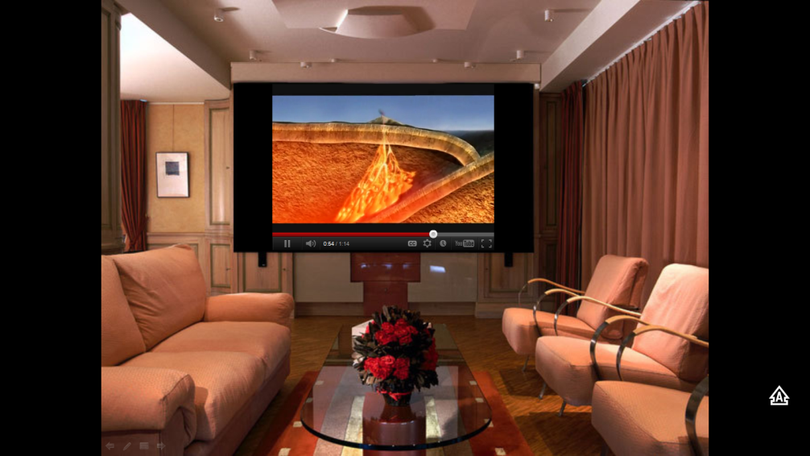

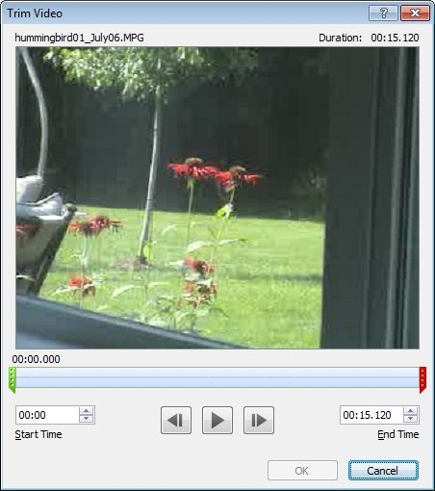
Optional Step 12 - Edit video on the slide - PowerPoint 2010 also enables you to do simple editing to the videos you add to your presentation. After you add the video, click it and click the Video Tools Playback tab. Click Trim video to display the video in the Trim Video dialog box. Then, just drag the green marker to the place you want the video to start and the red marker to the end point for the clip. Or if you prefer, enter the start time and end time values in the appropriate boxes. Click OK to save your edits. This sometimes does not work unless the video is yours.

Editing Your Streaming Videos in YouTube.

YouTube have recently introduced an editing facility onto the site. This is in its early stages and will certainly be developed more fully over the coming months and years. It allows you to do the following:
- Editing videos together
- Trim videos (particularly useful when extracting key points from a longer video)
- Transfer effects between videos and scenes
- Adding subtitles to videos
- Adding background music to videos
- Changing the visuals e.g. black and white, rotation of video etc.

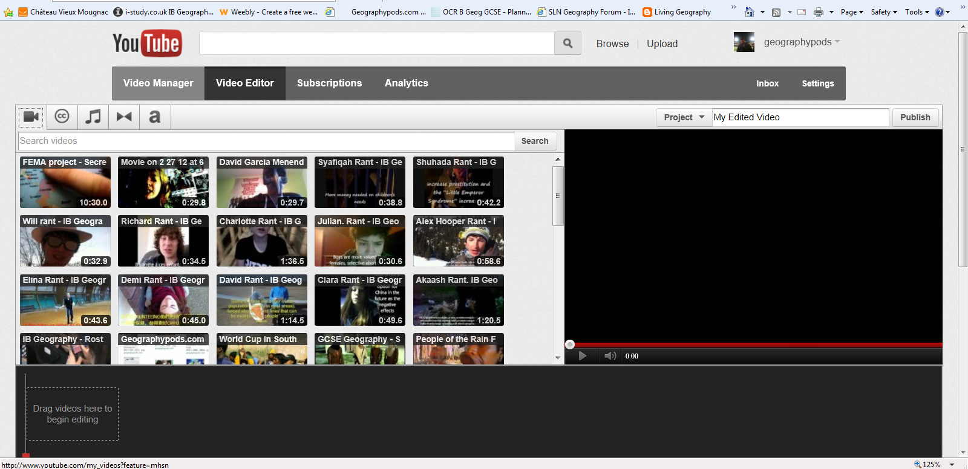
Step 13 – Go back to your YouTube homepage and navigate to video manager and then choose the ‘Editor Tab’ from the top of the page

You will only have your video that you loaded here earlier in the session (and any other videos that you may previously have uploaded). This is essentially a drag, drop, crop and divide exercise. See diagram below:
CC are videos with Creative Commons license. You can add these to your task. Type your subject into the search box and see what happens.
This is to add subtitles over the text. A particularly useful tool for the international setting
Music. These are free to use tracks with the timings to add to your video. Careful with copyright.

This is to add the effects between the edited videos. Slide, fade in etc

Video – will bring up a list of your uploaded videos. You can only edit your videos

Step 14 – Play with the different CC videos and try to also place your uploaded video somewhere in there too. Add some video change effects and some subtitles and perhaps even a soundtrack. Don’t forget to give your project a name and click on Publish.
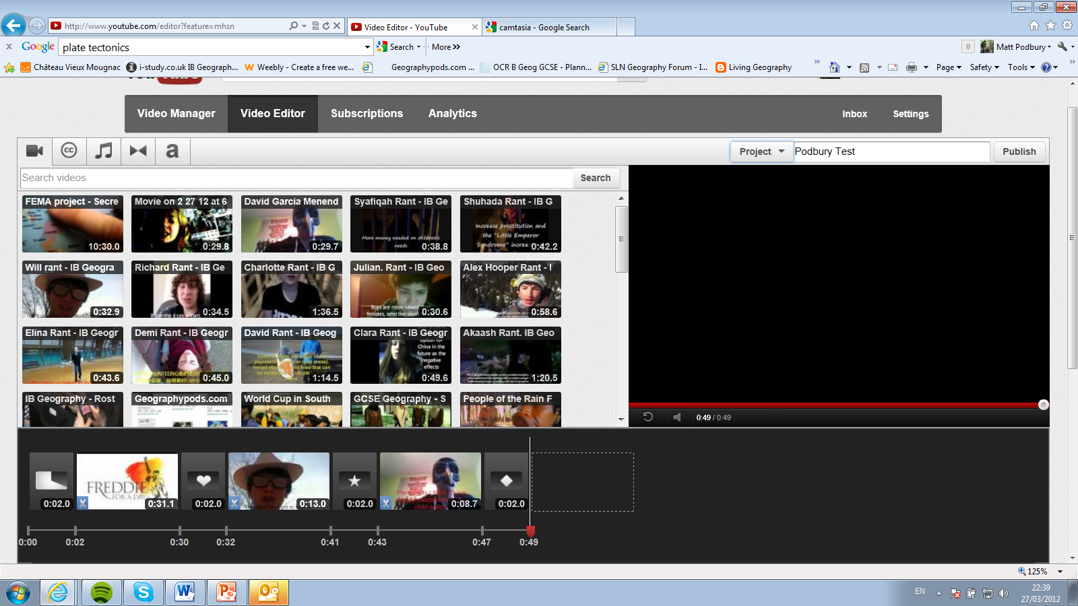

WELL DONE! Now you have your first edited video. Have a go at embedding it into a presentation using the instructions in steps 7-9. You will also be able to embed into your VLE or website with this code.
Notes
________________________________________________________________________________________________________________________________________________________________________________________________________________________________________________________________________________________________________________________________________________________________________________________________________________________________________________________________________________________________________________________________________________________________________________________________________________________________________________________________________________________________________________________________________________________________________________________________
Further notes – Permanent Copies of YouTube videos.
Videos sometimes disappear from YouTube and users like to take a copy of these videos just in case. Clearly there are copyright issues with this so make sure that you understand the legalities first. The best way to snag a video is using the site www.keepvid.com

Step 15 – Find the YouTube video that you want to snare. Copy its address into the bar below and then click on download
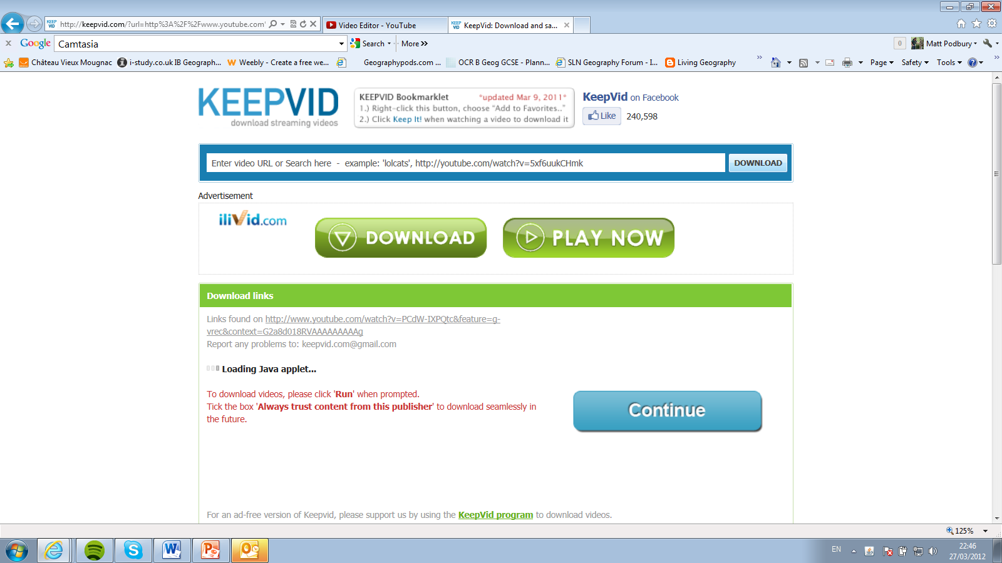
Step 16 – Choose the best option for you e.g. MP4 Max 480 (best quality). When you press continue, the video will be downloaded into your Videos folder of your computer/laptop. Simple as that!

