IB Freshwater – Importance of Wetlands
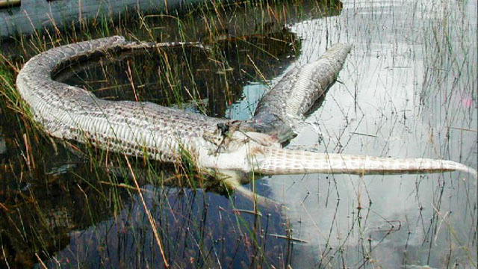
What happened in the picture above?
Task 1 – Using the web link on Geogaphypod.com, create a summary of the value of wetlands in the table below. You should aim for a 50 word summary of each.
Factor | 50 word summary of the importance.
Water Quality

Water Supply

Flood Protection

Erosion Control

Fish & Wildlife

Recreation/Culture /Science

