IGCSE Geography – Who uses the water?
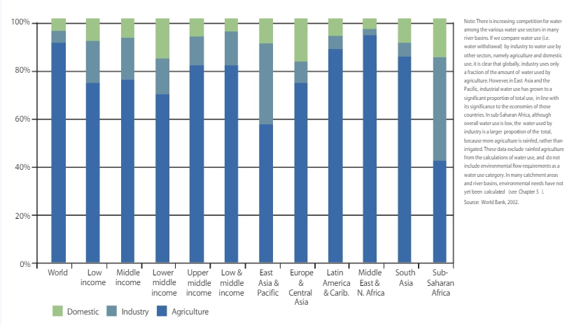
Task 3 - Study the image above (or download it by clicking on the blue tab above) and then complete the following questions.
i. Which world region uses the highest % of water for agricultural purposes? Can you think of two reasons why?

ii. Which world region uses the highest % of water for domestic purposes? Can you give two reasons?

iii. Which world region uses the most water for industrial purposes? Can you give one reason?

iv. Which is the only world region not the follow the global average trend of % of water used for agriculture?

