IGCSE Geography – Water Supplies
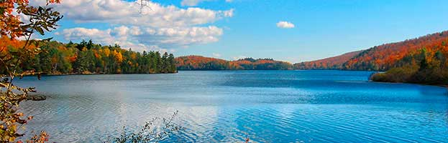

Read the introductory text on geographypods. Fill in the key information below.
Name the four global issues that cause water stress | 1  2  3  4
The worlds water supply is roughly divided into the following % figures
Salt water
Fresh water
Of the freshwater remaining, it is divided up into the following
Glaciers & icesheets
Underground
Surface water

Watch the ‘what is groundwater’ video on geographypods. Complete the key data points below.

What is groundwater?

What is an aquifer?

What is the water table?

How long can groundwater stay underground?

What is a spring?

Groundwater Supply 1 – Boreholes

Watch the video on geographypods all about boreholes.
In the space below briefly explain what a borehole is and how it works.
Explanation | Simple image from Google

Groundwater Supply 2 – Wells

Watch the video on geographypods all about wells.
In the space below briefly explain what a well is and how it works.
Explanation | Simple image from Google
Dug wells 1:45

Driven wells 2:17

Surface Storage Supply 1 – Reservoirs

Watch the video on geographypods all about reservoirs.
In the space below briefly explain what a reservoir is and how it works.
Explanation | Simple image from Google

Surface Storage Supply 2 – Desalinization

Watch the video on geographypods all about desalinization.
In the space below briefly explain what desalinization is and how it works.
Explanation | Simple image from Google

