IB Geography - Classifications of Water Scarcity
Physical Water Scarcity
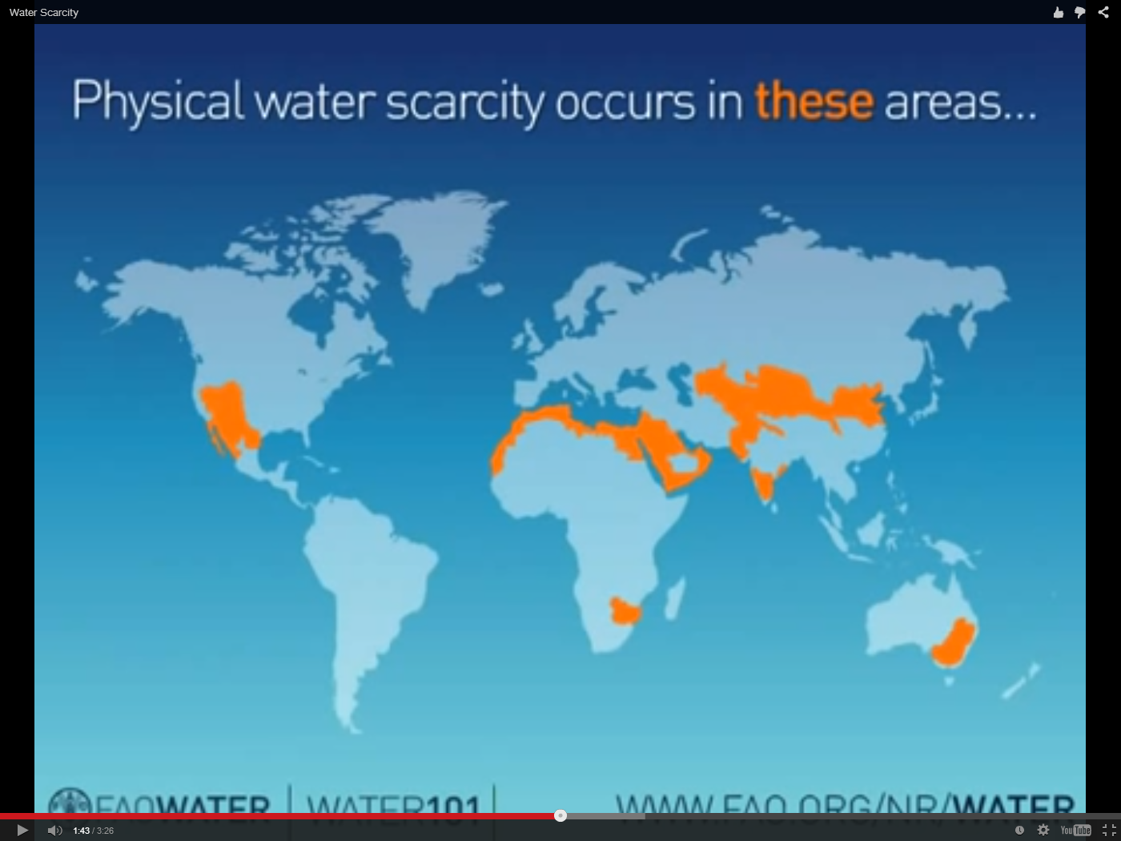

Economic Water Scarcity
