G8 Geography – Why is the Amazon Being Destroyed?

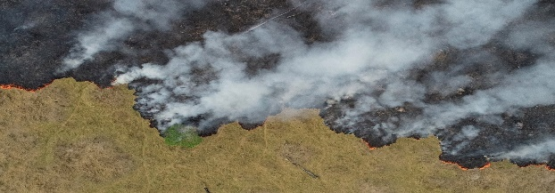
https://www.youtube.com/watch?v=SAZAKPUQMw0
1:45 – When did large-scale deforestation of the Amazon begin?

2.00 – Most of the resources in the Amazon were inaccessible. What did the Brazilian government do to open up the forest?

2.19 – Where did most of Brazil’s population live at this time?

2.25 – Where did the government want to move people to & why?

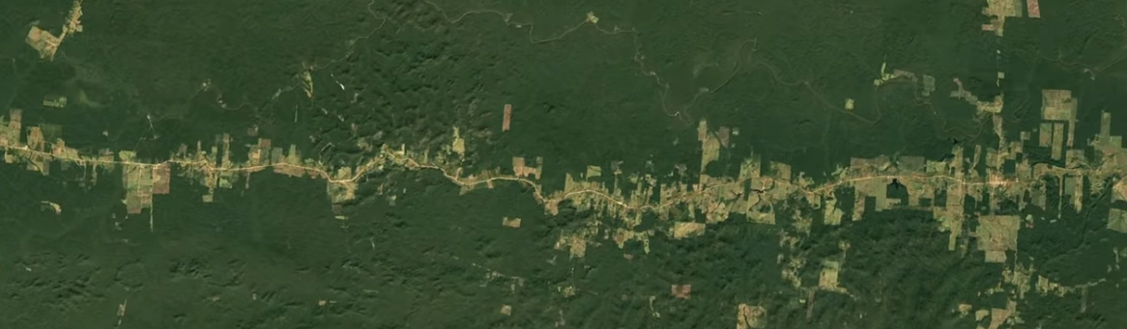

2.33 – What does the image above show?

2.44 – What did most of the settlers turn their land into? What problems did this cause?

3.15 – How are soy beans responsible for deforestation in the Amazon?

4.50 – How did Marina Silva and the Brazilian Government reduce high rates of deforestation?

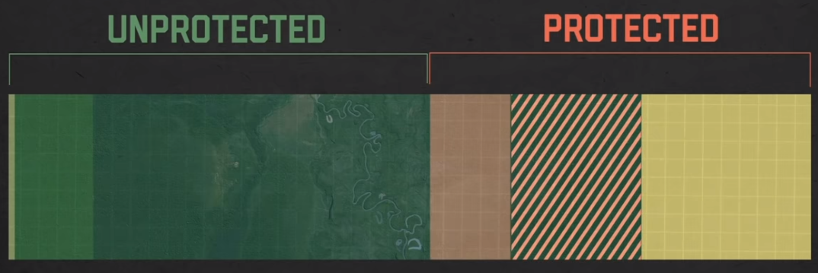
6.12 – What percentage of the rainforest was protected by 2012?

6.20 – What did the ‘Forest Code’ say?

6.35 – What was IBAMA and what did they do?

7.05 – Give an example of a company who signed the ‘Soy Moratorium’ and describe what this meant.

7.33 – Name two countries that gave money to Brazil to help it protect the Amazon.

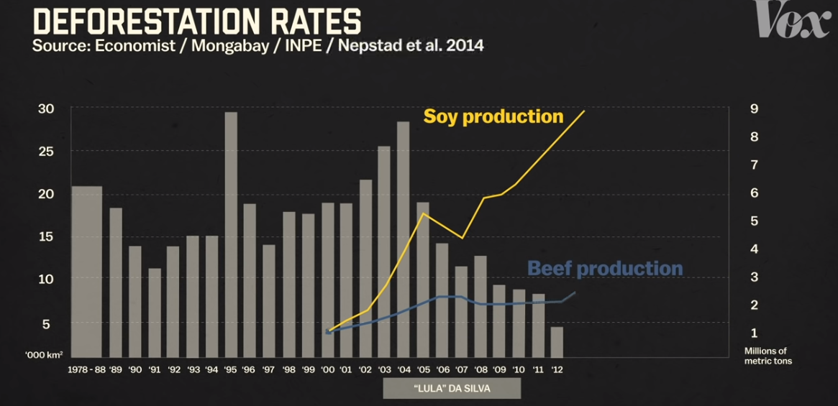
7.35 – 8:03 – Explain how deforestation rates dropped despite soy and beef production increasing?

8.06 – Who are the ‘Ruralistas’ and how has their influence been changing since the early 2000’s?

8.56 – Who is the person below and how has he impacted on the protected areas and deforestation?

Approximately, how much of the Amazon rainforest has been cleared in total?

What could happen if this reaches 20- 25%?

