Understanding Wave Cut Platforms – IGCSE Coasts - Erosion

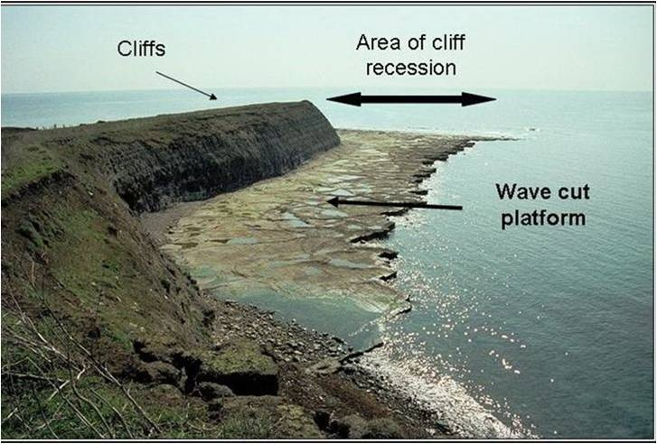
Make a sketch of this feature in the space below and add annotations to explain formation.

Exam Corner – Explain the formation of a wave-cut platform. (4)

When you have finished writing your answer, check how you did. Watch this video from the Time For Geography Team. Make any corrections you need to.

