IGCSE Geography – Types of Ocean Waves

Task 1 - Define the following two important wave terms.

Swash
Backwash
In the space beneath, draw a sketch the show the processes of swash and backwash.

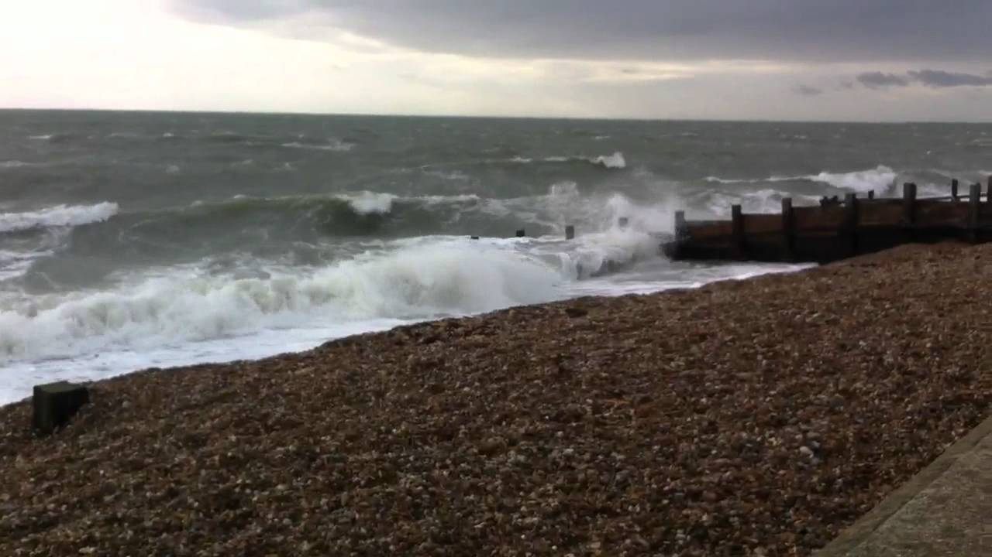
Task 2
Destructive or Deconstructive Waves – Diagram here

1

2

3

4

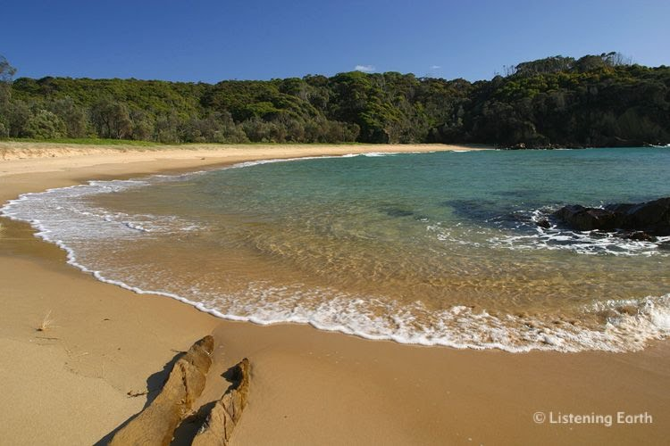
Constructive Waves – Diagram Here

1
2
3
4

