Tribal Life in the Brazilian Rainforest v My Life in ____________________ – Grade 8 Geography
Brazilian Tribe Image | Description | My France Image | Description
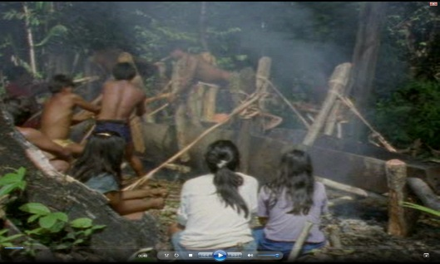

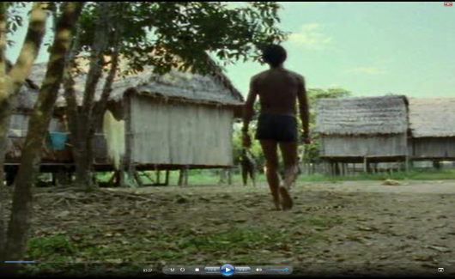

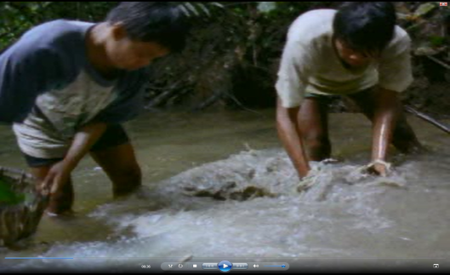

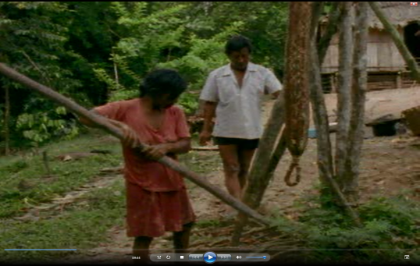

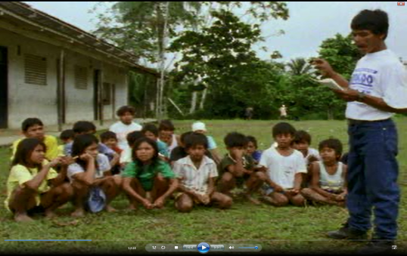 |  | 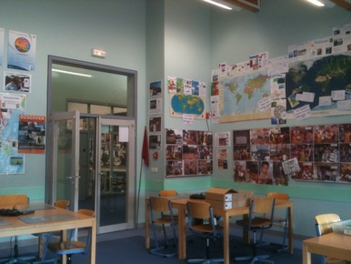
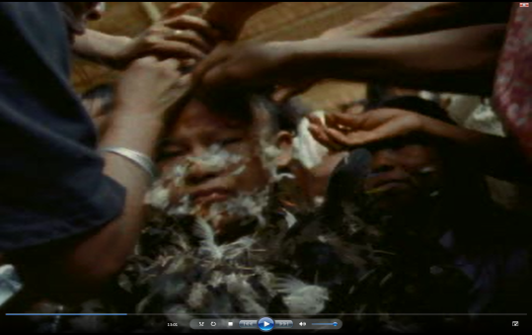

“Tribal people of the rainforest lead a life that is much worse than ours. They don’t have electricity and all the goods that go with them. They don’t have cars, heated houses, Facebook, Internet, shops and banks”. To what extent do agree with this statement. (Target 100 words)

