G8 Geography – The Tribe & The Threats To Their Way of Life
Task 1 – Complete the table beneath using the information from the website embedded on geographypods.com
Group / Factor | Photo | How does it cause contact to happen? | What is the potential effect of the contact on tribe
Cattle Ranchers | 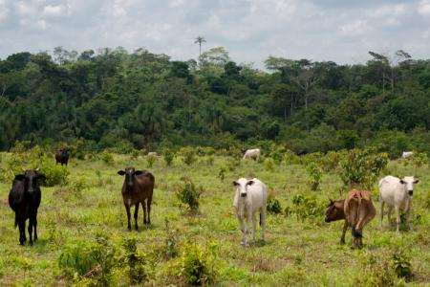
Disease | 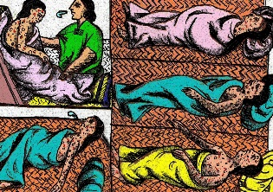
Missionaries | 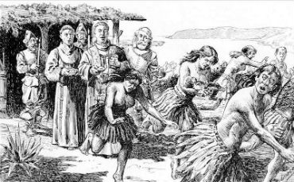
Colonists | 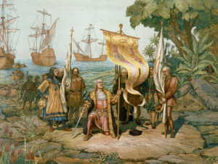
Loggers | 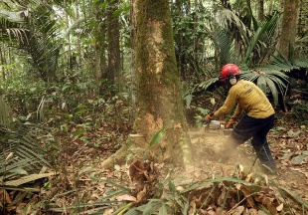
Roads | 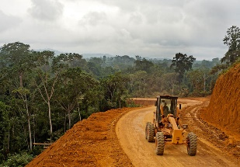

Photo Interpretation
Task 2 – Study the photo below. Explain the situation that is occurring in this photo and what the potential outcomes may be for the people of the village.
