The Water Balance – Graphing Changing Supply & Demand
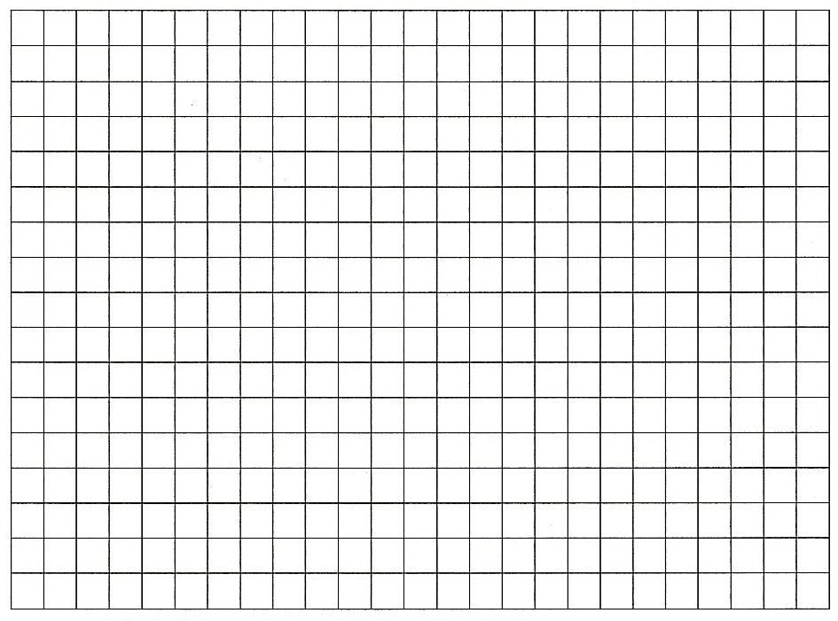
Starter: Make a sketch of the water balance graph from geographypods onto the blank template above. You can use two square per month on the X axis and one square to represent 10mm of precipitation on the Y axis.

Task 1a. In which months is there a water surplus?

Task 1b. Why is there soil moisture recharge in October?

Task 1c. When is field capacity attained?

Task 1d. Why is water deficit not shown on the graph?

Task 1e. Explain the pattern of evapotranspiration on the graph. Is this a northern or southern hemisphere model?

Task 1e. Copy the information from geographypods to form a spider diagram of key terms beneath.

