The Magic Washing Machine
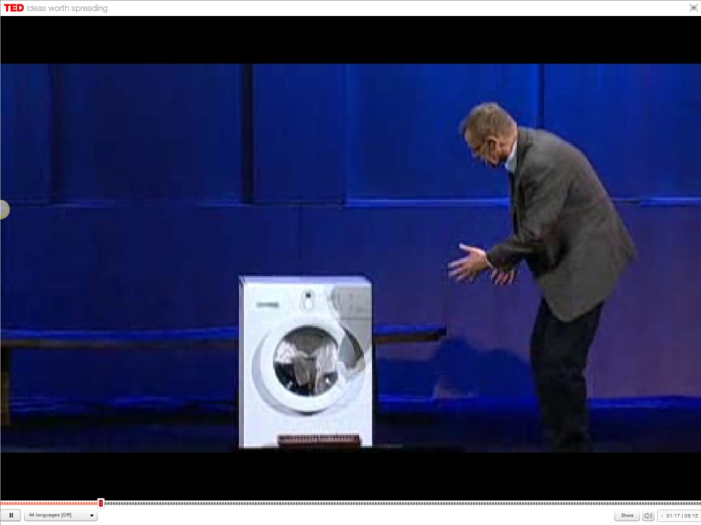
IB Geography - Reducing Gender Inequities
5. So, according to Hans Rosling, how can washing machines lead to an improvement to the lives of women in the developing world and a narrowing of the gender inequality gap?
4. How do these remainder of these women wash their clothes and where do they get their water from?
3. How many people have access to washing machines in the world?

How many have to hand wash?
2. How many people live on less than $2 per day
- Life before washing machines in Sweden …

