G12 IB DP Geography - The GeoPolitics of Energy

Task. Using the map beneath and the newspaper articles hyperlinked on the geographypods.com page, annotate on key issues geopolitical impacts of increased demand for oil production. You work should cover the following titles 1. International Relations 2. Political Instability 3. Emissions Quotas 3. Carbon Tax 4. NGO Pressure (make sure you define an NGO too)
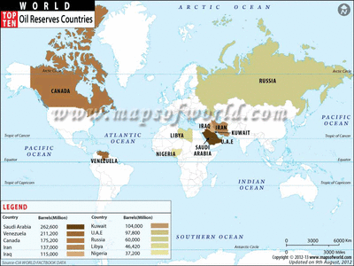
International Relations – Venezuela USA
BP Deepwater Horizon
Political Instability – Hostages in Nigeria
UK & Emissions Targets
Carbon Tax – France 2014
Political Instability - Libya

