The Balance between environmental concerns and economic development – China, Pearl Delta.
Describe the location of the Pearl Delta.

Why is the location an advantage for businesses?
IGCSE Geography – Environmental Risks
Identify the environmental impacts of industrial activity on the Pearl Delta and create a second spider diagram in the space beneath.

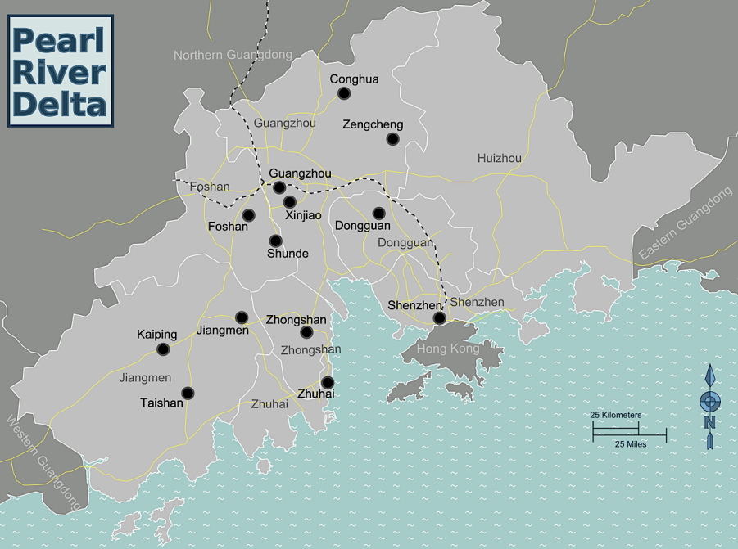
Task 1 – Annotate this map using the information on page 198.
Read the Independent article and summarise the effects of ‘Made in China’ pollution on the USA.
Made in China , USA Pollution
Environnemental impacts on the Pearl Delta
How Acid Rain Forms: Annotated diagram here please !

