G8 Geography – That Terrible Teenage Affluenza!

Task 1 - What is the meaning behind this video?

How can having so called 'teenage affluenza' affect our view the world around us?

Task 2 - What are your daily hardships?

Give your top five #firstworldproblems. Don’t forget the #

Create a meme, personal to you, and paste an image of it in the space below

Task 3 - What does Drake have / What doesn’t he really need ? Annotate the photo beneath.

What does the girl have? Annotate the photo below

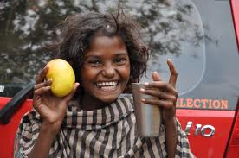

Task 4 - What 9 Things Does The Street Child Need?

