G7 Geography – Decolonising the European Wall Building
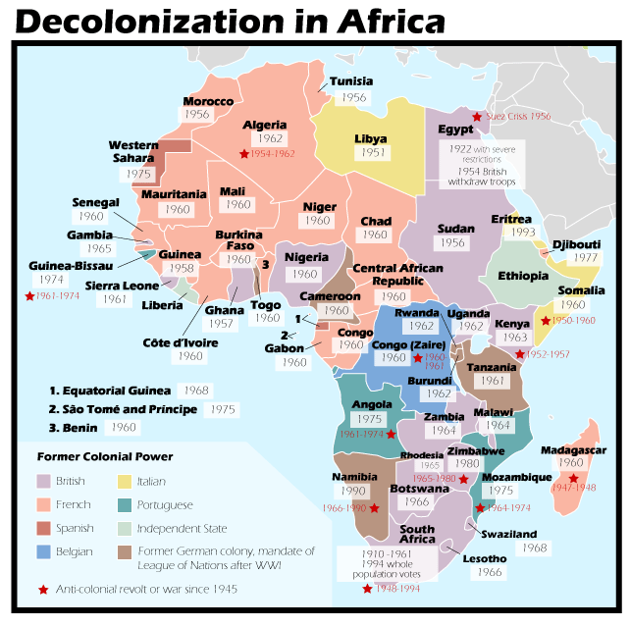
Task 9 - The map above shows how the continent of Africa was ‘sliced up’ into colonies and then how the dates where decolonisation happened, and the countries started to gain their independence once again.

Identify which two European countries dominated the African continent.
1

2

Which of these two countries was the first to pull out of its colonies? What decade was this?

Which decade the second country mostly pull out its colonies? Which decade did this mostly happen?

Can you think of any reasons why this pull-out (decolonization) happened in such a short period of time? Clue: Think of a major world event involving these two countries.

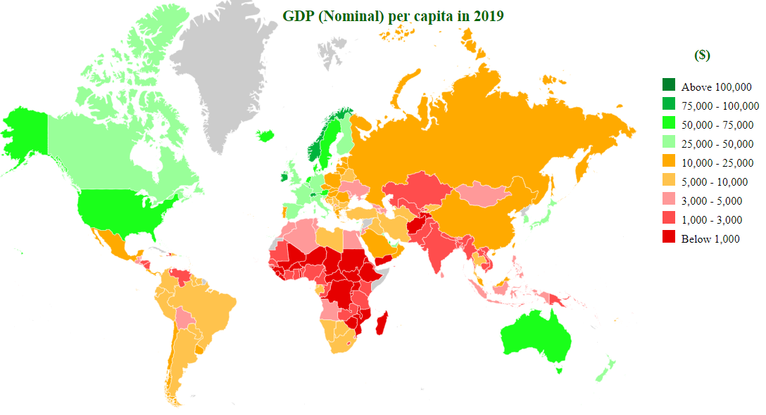

Having had their resources taken, their peoples enslaved, their cultures destroyed, and their languages dictated to them, the populations of these colonies were left to pick up the pieces after years of colonial control. All the above clearly helped to boost the economies and prospects of the colonizers and has certainly contributed to their current levels of economic success (HIC).

Check out the GDP per capita map of the world in 2019. Describe the differences in wealth between those former colonized countries and those countries in Europe who used to control them.

Watch the Channel 4 video embedded on geographypods. Why are people attempting to get to Europe now? What are they escaping from?

Why does building land walls lead to higher death rates elsewhere?

The image on the next page is a headline from a famous British newspaper called The Times. This is a story about a migrant who had stowed away on a flight from Kenya in the landing gear of the plane.

- Why did this person from Kenya try to get the UK like this?

- Do you have any comments or observations to make about the content of the article?

Source

