G6 Geography – Pirates and The Maritime Silk Routes
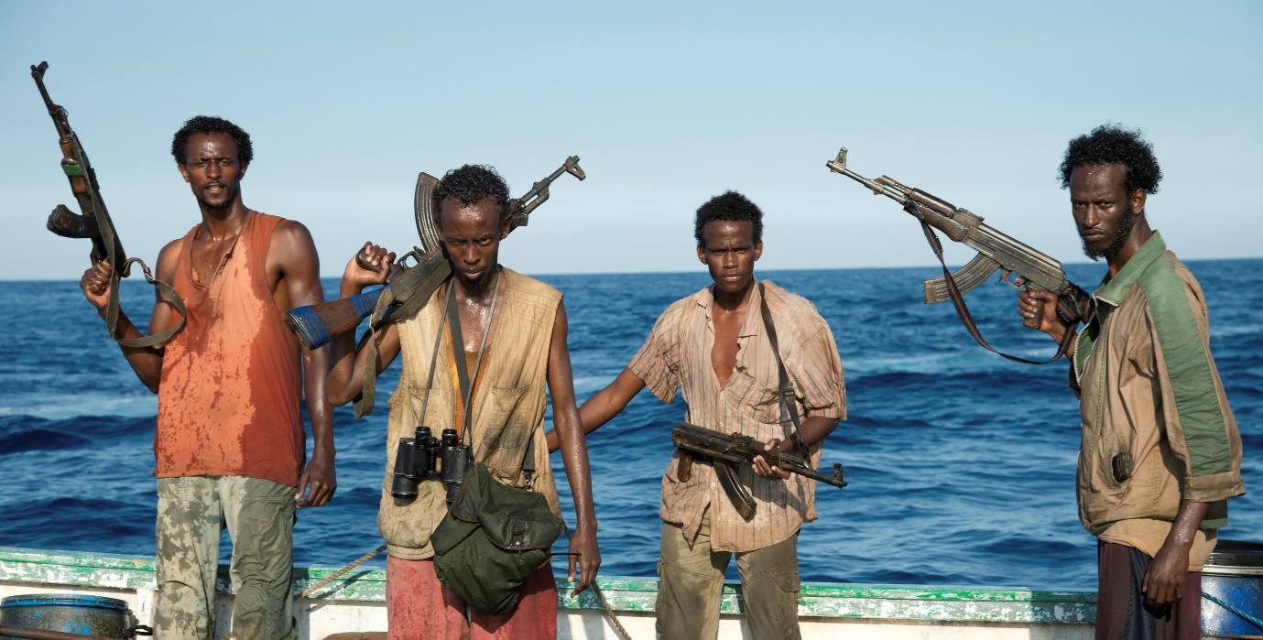

Watch the embedded video on geographypods and complete the note taking activities below.

Why is Somalia an LIC? | Where is Somalia
 | 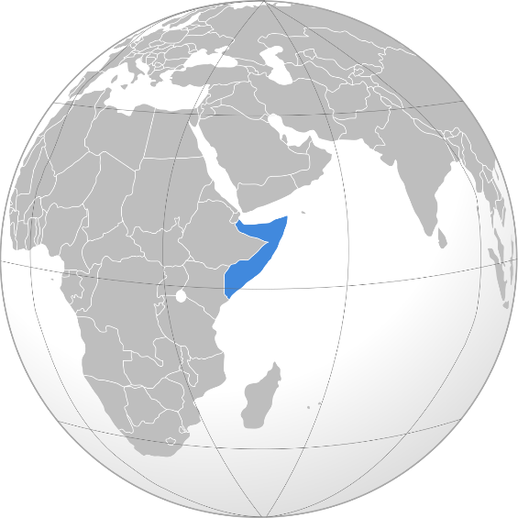

Study the map above and explain why pirates from Somalia are strategically well placed to interrupt the flow of ships from Asia to Europe along the Maritime Silk Road.

Explain how the ships are taken hostage.

Explain how the negotiations to free the hostages takes place and state how long it can take.

What is operation ‘Ocean Shield’ and who organises it?

Is there any way to solve the problem of piracy off the coast of Somalia?

