G6 Geography – The Ever Given Container Ship Incident 2021
Using the video on geographypods, complete the research task below. You can delete the text in each of the boxes before you start writing.
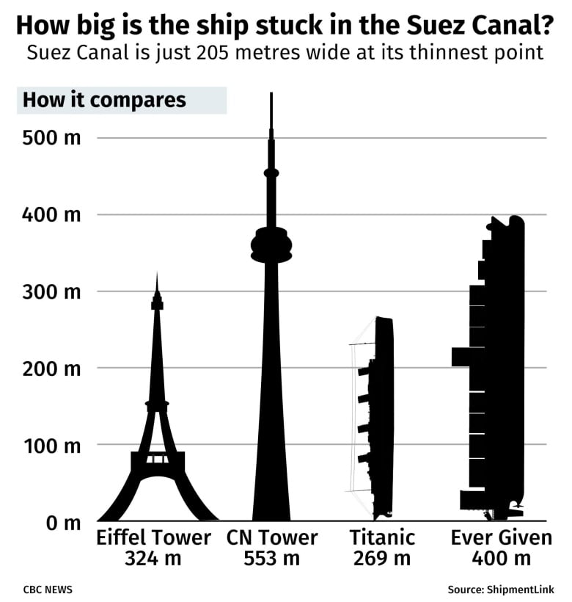
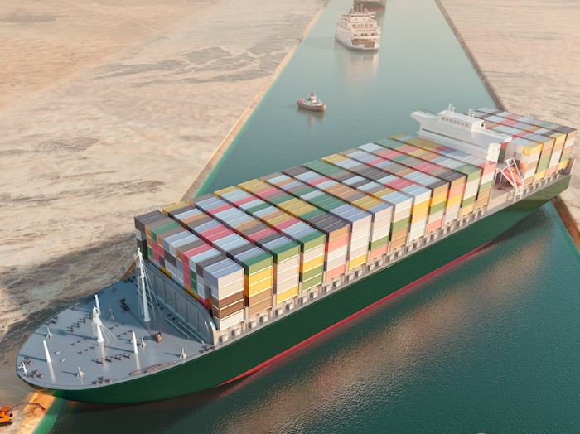
How did they free the ship and how long did it take?
What impacts did this have?
Where it got stuck and why?
Ever Given – Facts about the ship

