Migration – Two sides to the story

Task: Study both images underneath and complete the analysis as set out.
Daily Express recent coverage of the migration situation. Do the headlines portray migrants in a positive or negative way and which particular impacts are highlighted in the headlines?
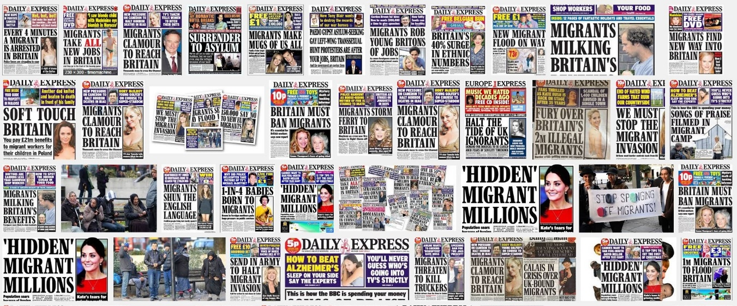
Your response here:

Your own thoughts on the headlines (right, wrong, informed, misinformed etc)

A now famous photo of a migrant father cradling his young children.
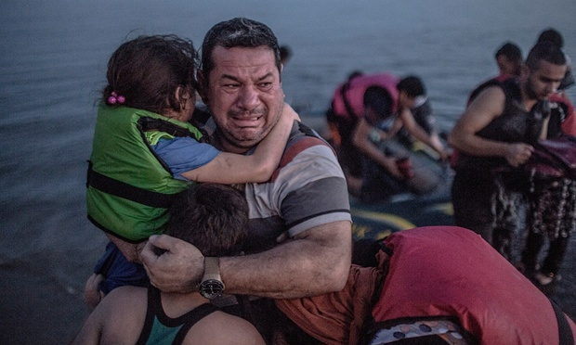

- Are they lucky or unlucky? Why?

- What will they need in the next day?

- What will they need in the next month?

- What do you think has happened to them in the last 24 hours?

Who is the terrified man and his children? Click here to read more about the man and his children and then create a 100 word summary of the story beneath.

