G7 Geography – Why Build Walls?
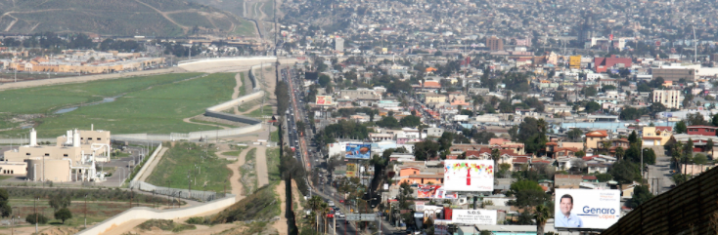
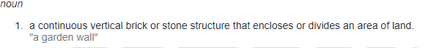
Task 1 – In the space below, list down between 5-10 reasons why walls are built.

1 | 6
2 | 7
3 | 8
4 | 9
5 | 10

Task 2 – Now choose your top three reasons and write them into the diagram below with a short explanation and if possible, a place in the world where you know this exists.

Reason | Explain a little more | A place in the world
1 –

2 –

3 –

What Do We Use to Build Walls?

In the space below, make a list of five common materials that a wall could be made from. For each, state on advantage and one disadvantage

Material | One advantage | One disadvantage

You are now going to see three photos. Annotate around each photo some of the strengths, weaknesses, and key design features. Do not forget to suggest what you think they have been built for and perhaps, where.

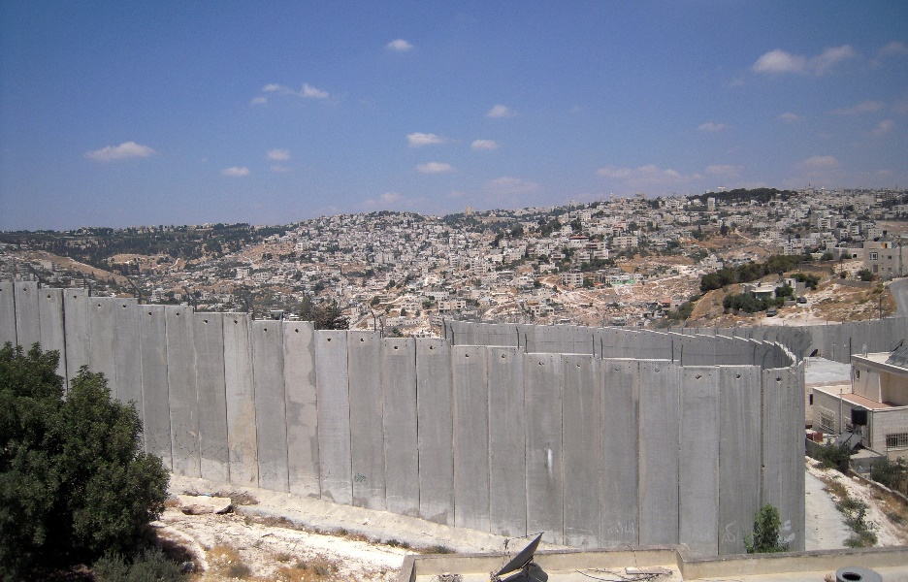

Why was it built? | Where?

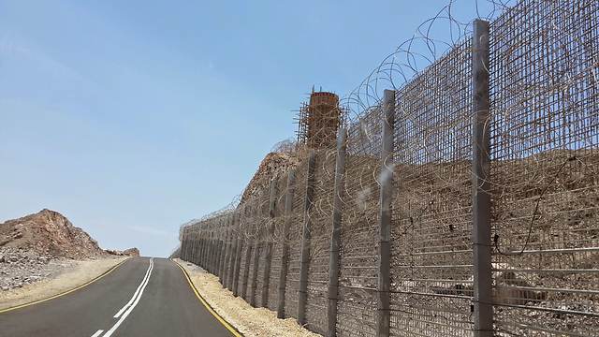

Why was it built? | Where?

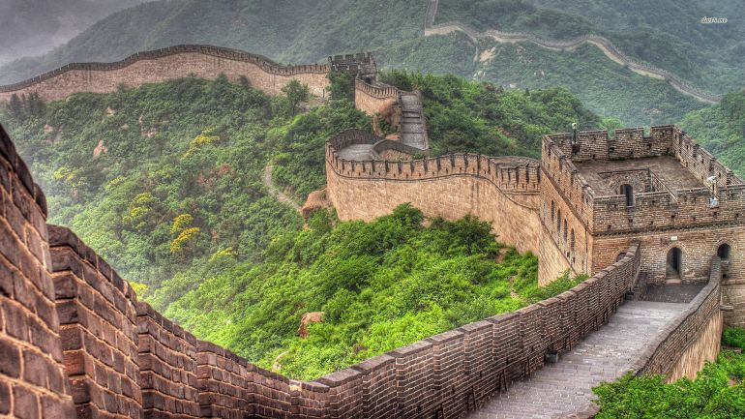

Why was it built? | Where?

