Hazard Responses | IB Geography  IB Geography
Case study booklet of hazards responses based on the short, medium and long term and related to community, national and international level of management. This should be completed for each of your case study hazard events. |  | Optional Theme D
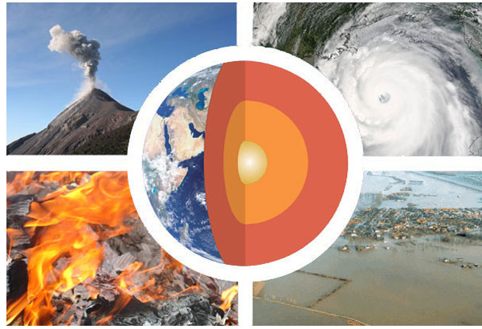

MEDC Case Study - Hurricane Katrina 2005

Response | Community Level | National Level | International Level | Notes
Short Term

Mid Term

Long Term

LEDC Case Study – Cyclone Haiyan – Philippines 2013

Response | Community Level | National Level | International Level | Notes
Short Term

Mid Term

Long Term

MEDC Case Study - Recent Drought in California
Response | Community Level | National Level | International Level | Notes :  .
Short Term

Mid Term

Long Term

LEDC Case Study - Recent Drought in Horn of Africa

Response | Community Level | National Level | International Level | Notes
Short Term

Mid Term

Long Term

MEDC Case Study – Japan 2011

Response | Community Level | National Level | International Level | Notes
Short Term

Mid Term

Long Term

LEDC – Haiti 2010

Response | Community Level | National Level | International Level | Notes
Short Term

Mid Term

Long Term

Human Induced - AZF Toulouse 2001

Response | Community Level | National Level | International Level | Notes
Short Term

Mid Term

Long Term

