G8 – Geography – Factors Affecting Global Tourism Trends

Study the picture sheet and the global tourist numbers graph carefully. The graph shows you patterns and trends for tourism growth in the major global regions from 1950 to 2020 (predicted). Number each of your images on the first sheet and then complete the table below carefully.

Photo Number | What does it represent? | How does this affect tourism? | Link with one other photo….
1 | Increase in safari tourism to Africa (Kenya & Tanzania) | Increased tourism to African countries since the 1990’s | Links in with A380 photo 9 because planes can now carry more passengers further than ever before (and for less cost) to long haul destinations such as Kenya from France.
2

3

4 | New destinations opening where traditionally there didn’t used to be any tourist at all – Dubai.
5 |  | People who have a higher level of disposable income (money that’s left over after paying all the bills every month) are able to afford more regular holidays and are likely to spend more in tourism destinations.
6

7

8 | COVID-19 impacts on tourism globally.
9

10 |  |  | Although this is a natural hazard event and killed many tourists in 2004, it links in with photo 7 as it puts tourists off travelling to places where they may feel unsafe.
11

12 | Terror attacks in Paris and in Nice. Carried out by terrorists and calculated to hit tourist centres to maximise fear and media coverage

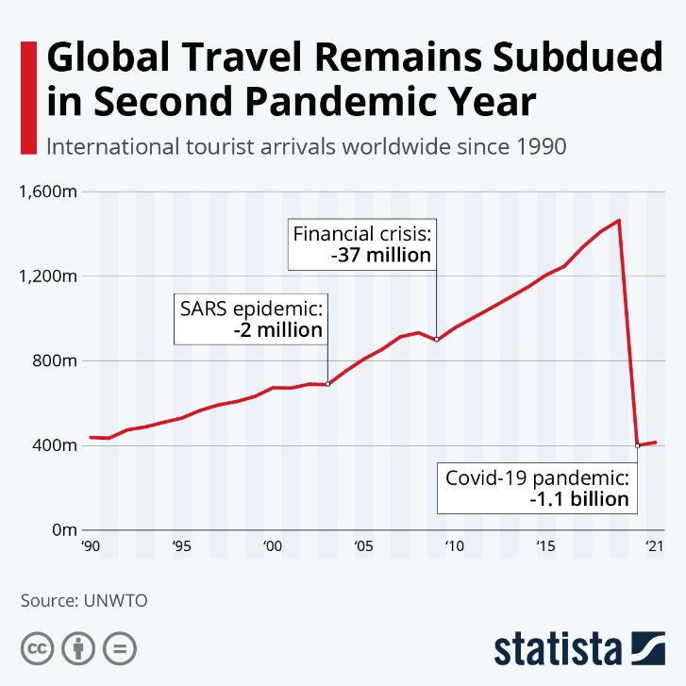
Describe the trend in tourism after COVID-19 struck in 2020. Use data in your response.

