IB Geography – Sustainable Tourism (The Basics)
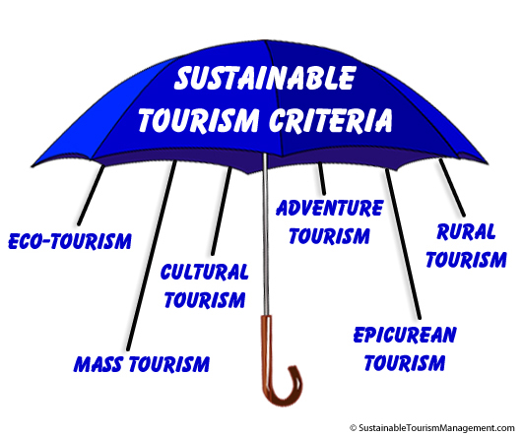

Sustainable tourism: Sustainable tourism is tourism attempting to make a low impact on the environment and local culture, while helping to generate future employment for local people. The aim of sustainable tourism is to ensure that development brings a positive experience for local people, tourism companies and the tourists themselves. Sustainable tourism is not the same as ecotourism. | Carrying capacity: The maximum number of people that may visit a tourist destination at the same time, without causing destruction of the physical, economic, socio-cultural environment and an unacceptable decrease in the quality of visitors' satisfaction. The IB splits carrying capacity into environmental carrying capacity and perceptual carrying capacity. Environmental carrying capacity is the maximum number of visitors before environmental harm is done. Perceptual carrying capacity is the maximum number of visitors before visitors consider an impact like noise to be excessive.
Ecotourism: is responsible travel to fragile, pristine, and usually protected areas that strive to be low impact and (often) small scale (as an alternative to mass tourism).

