Sport, Leisure, Tourism – Option E
Define Sustainable tourism _____________________________________________________________________________________________________________________________________________________________________________________________________________________________________________________________(2)

How does sustainable tourism differ from eco-tourism ?
_____________________________________________________________________________________________________________________________________________________________________________________________________________________________________________________________(2)

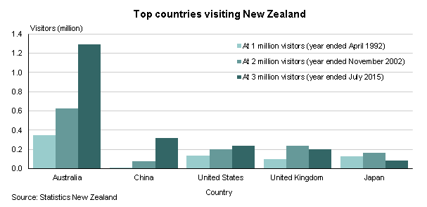
Explain two reasons for increased visitor arrivals from China. [3+3]
____________________________________________________________________________________________________________________________________________________________________________________________________________________________________________________________________________________________________________________________________________________________________________________________________________________________________________________________________________________________________________________________________________________________________________________________________________________________________________________________________________________________________(3+3)

Explain two reasons for decreasing visitor arrivals from the United Kingdom. [3+3]

____________________________________________________________________________________________________________________________________________________________________________________________________________________________________________________________________________________________________________________________________________________________________________________________________________________________________________________________________________________________________________________________________________________________________________________________________________________________________________________________________________________________________(3+3)

Explain two cultural factors that affect participation and success in international sport. (2+2)

_____________________________________________________________________________________________________________________________________________________________________________________________________________________________________________________________________________________________________________________________________________________________________________________________________________________________________(2+2)

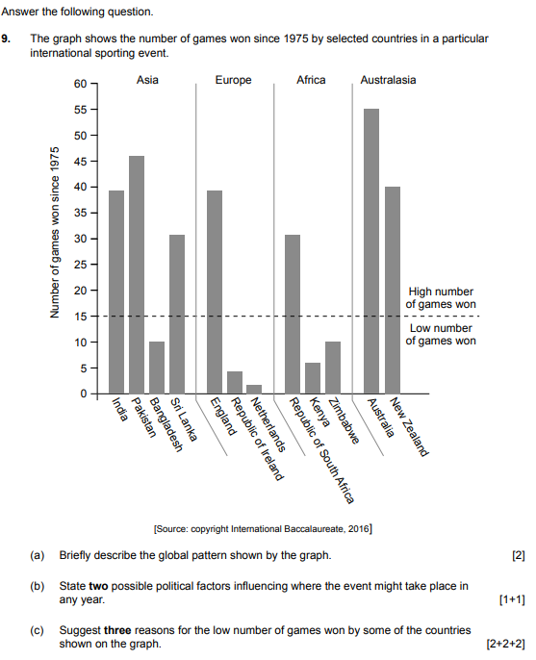

A

B

C

A

B

C

The environmental impacts of tourism are always greater than the socio-cultural impacts. Critically examine this statement in relation to one or more destinations. (10)
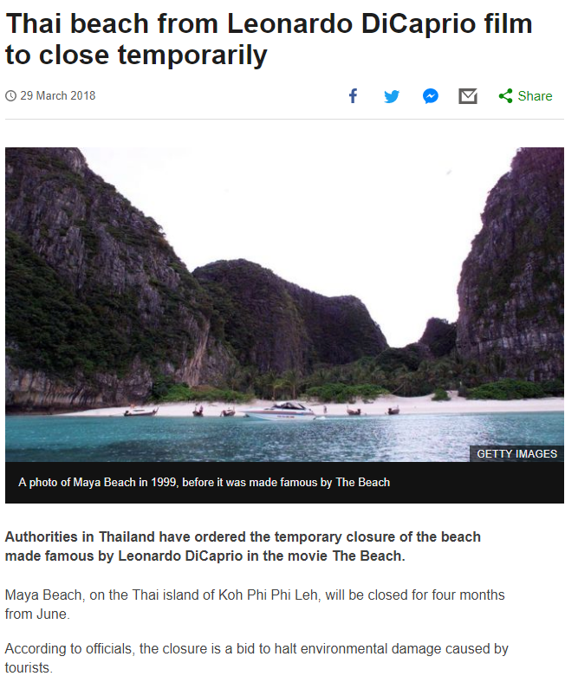
**Group task **

Examine the effectiveness of using sport and recreation to promote urban regeneration. (10)

