IGCSE Geography – Spit Formation – The Exam Question
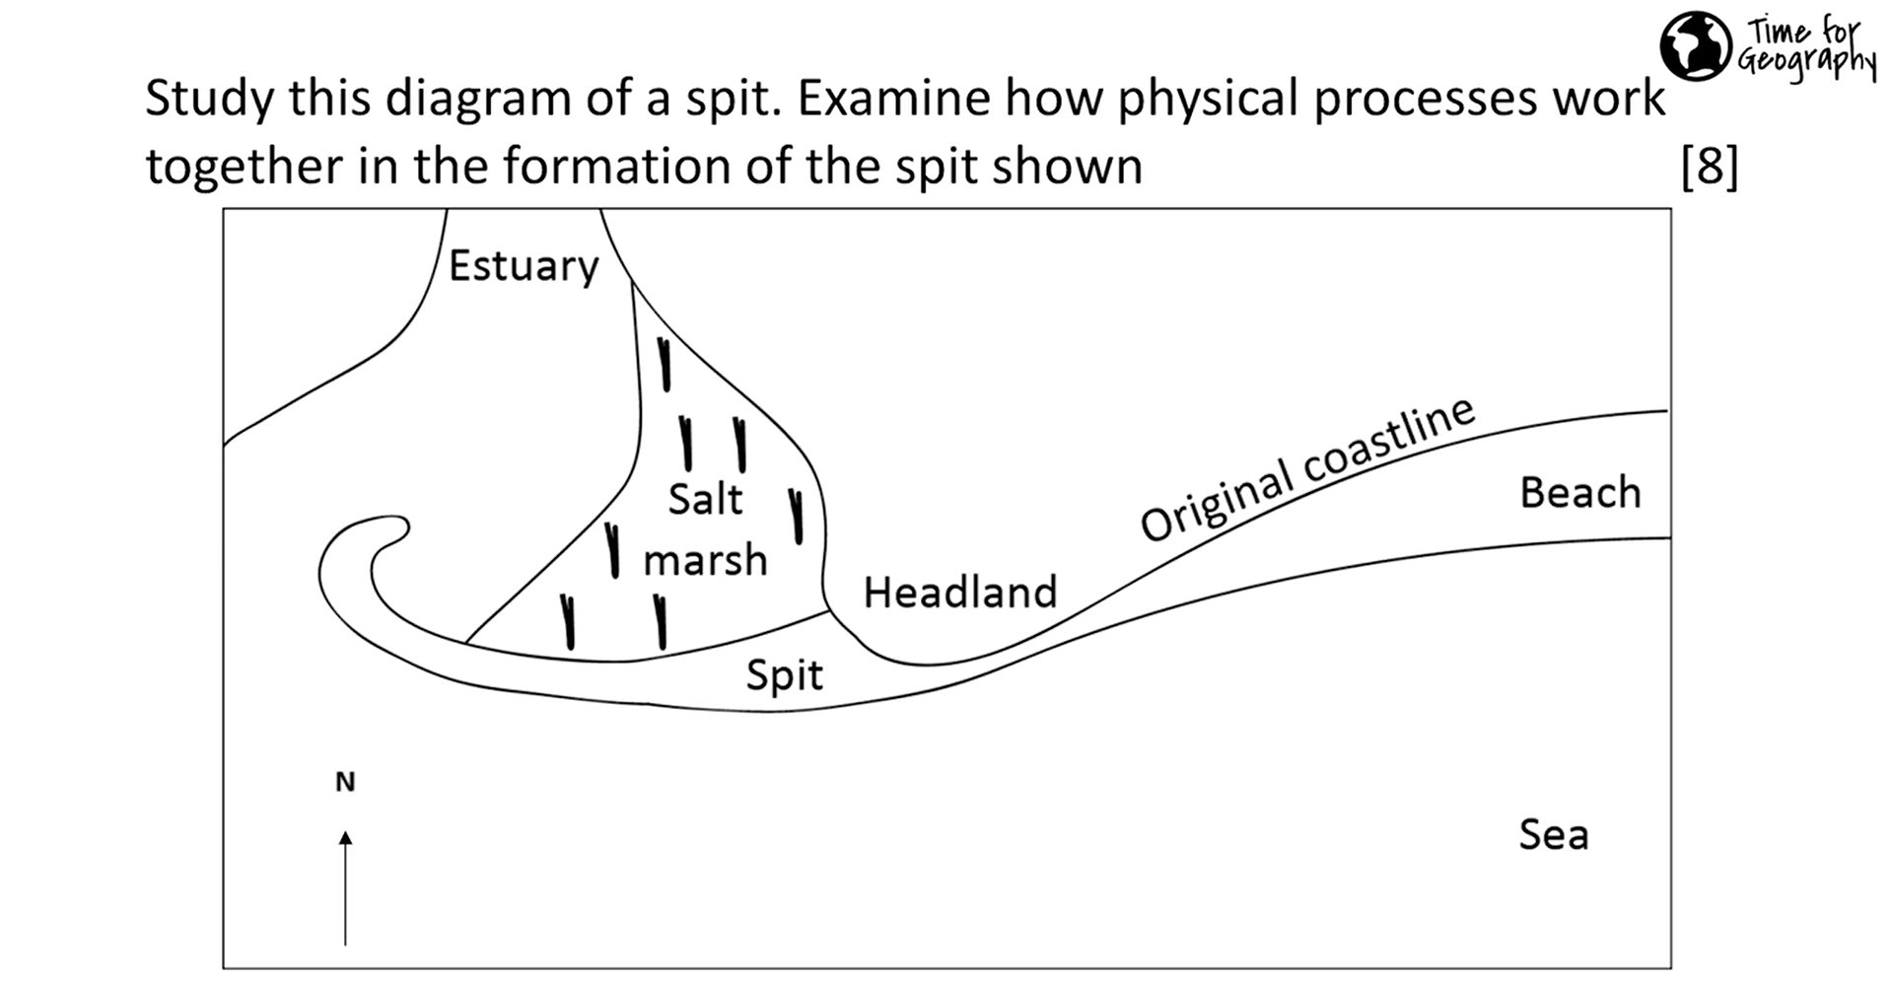
The image above is taken from the Time for Geography Site. In the IGCSE, this question would be worth 7 marks and not 8. You remember what you should do - P.E.E.L (the E for evidence, comes from the diagram above).

Have a go at answering the question in the space below. If you would like to attempt the question with the aid of the interactive video, click this link.

