|  |
| --- |
| **G8 Geography – Switzerland & South Sudan – Fact Finding Mission** |

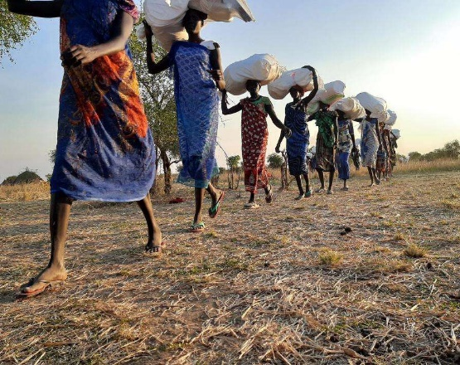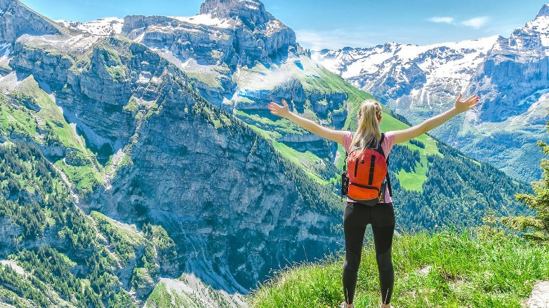

HDI =

HDI =