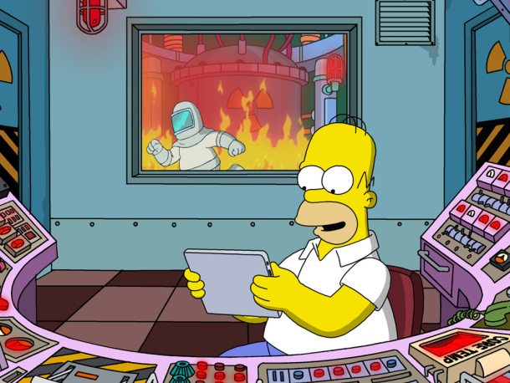

**iGCSE Geography - Siting A Nuclear Power Station - Checklist**