IGCSE Geography – Settlement Shape
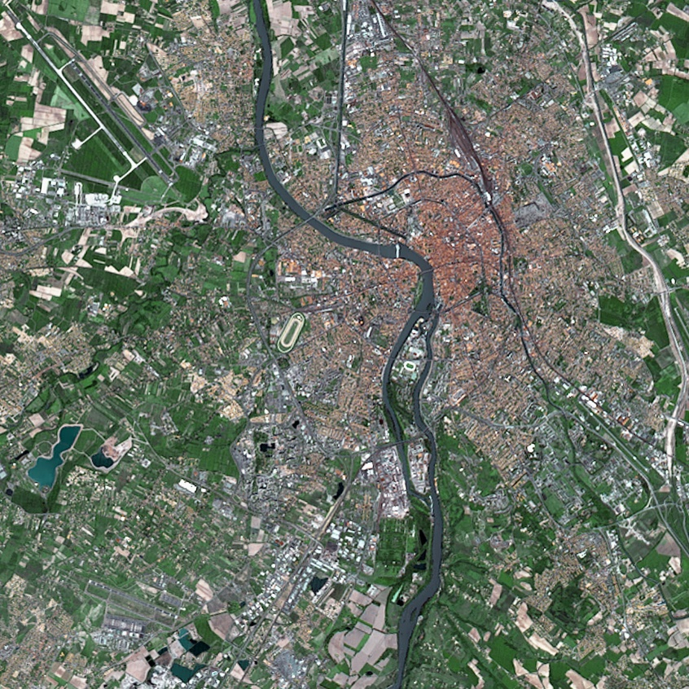

Settlements can be split into three broad categories depending on their shape and features as viewed from the air. Take the image above for example. It shows the city of Toulouse in the south of France. From the air, you can clearly see that the settlement has been built up around:

1
2
3
4

Draw a small circle around the CBD of the city of Toulouse

Label the River Garonne

Label the Canal du Midi

Label the Rocade / Ring Road

Label Pont Neuf

Label Blagnac Airport

Dispersed Settlement
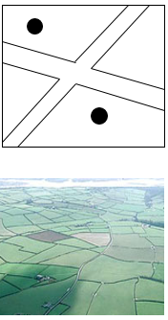
Definition:

Label to show key features.
Linear Settlement
Define:

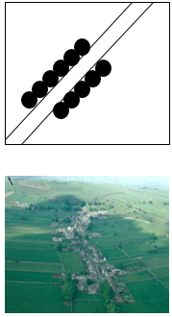
Label to show key features

Nucleated Settlement
Definition:
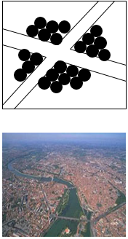

Label to show key features
Using an IGCSE Paper 2 Map Extract, find examples of linear nucleated and dispersed settlements.
Type of Settlement | Name | Grid Reference | Evidence
Linear | 1  2
Nucleated | 1  2
Dispersed | 1  2

Go back to the front page. What type of settlement is Toulouse? How do you know?

