IGCSE Geography – Settlement Service Provision Comparison
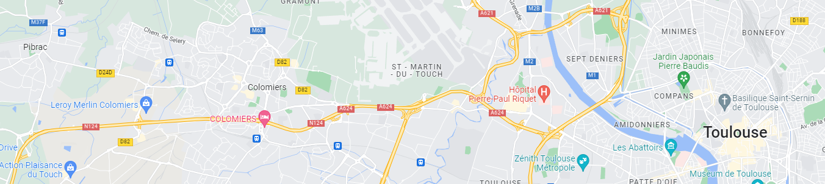
Use the hyperlinks below to access data for each of the three towns and fill in the data.
 | Pibrac (Low Order) | Colomiers (Middle Order) | Toulouse (High Order)
Population
Population density /km2

Using Google Maps, type in the name of the settlement followed by the name of the following services and make a rough guess of the number in each of the three settlements. The information in ( ) does not need to be typed in.
 | Pibrac (Low Order) | Colomiers (Middle Order) | Toulouse (High Order)
École (education not driving!)

Garage

Piscine municipal

Tennis

Universite

Supermarché

Centre commercial

Metro (present or future).

Fill in the last column of the table below. You will need to use your stylus pen or add a text box.
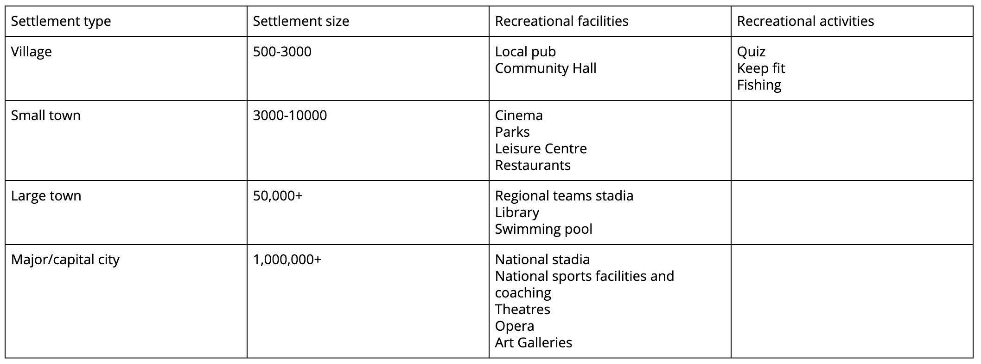

Plotting the Sphere of Influence of Toulouse, Colomiers & Pibrac

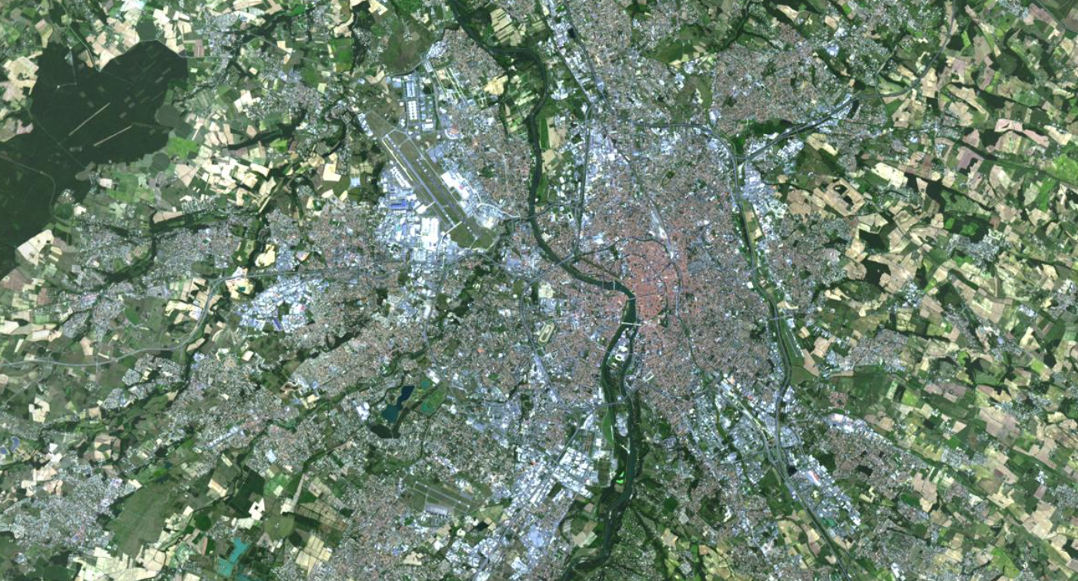

Homework – Characteristics of the CBD of Toulouse

You are going to carry out some research on the CBD of Toulouse. Many of you have been there multiple times and you can use your memories together with Google Street View to complete the research grid below. You are going to stay in the area around Place Capitol and Rue d’ Alsace Lorraine.
Once your have completed your research, you are going to PEEL answer the 7-mark question below using the mark scheme to guide you.

Factor | Height of buildings | Price of the land (M2) | Example of high order shops | Examples of entertainment facilities | Public Transport options
Examples

2c For a named urban area you have studied, describe and explain the characteristics of the
Central Business District (CBD).
Name of urban area ..........................................

