IGCSE Geography – River Processes
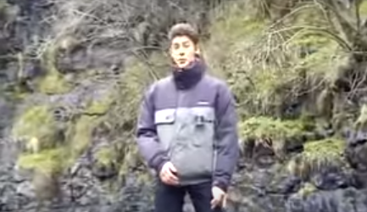
Hello !
Is it me you’re looking for?
Task – The four types of river erosion. Using the information on geographypods, complete this table.

Type of erosion | Explanation | Rough sketch cartoon of the process
Hydraulic Action

Attrition

Abrasion

Solution

Task 2 – Make a note of the different factors affecting erosion using the two subheadings below.

Physical Factors Causing Erosion | Human Factors Causing Erosion

Task 3 – How rivers transport materials. Study the image on geographypods / textbook and add labels and further annotations to the wonderful diagram below.
