Reducing Disparities

Discuss the different ways in which disparities can be reduced with an emphasis on the following:

- Trade
- Market Access
- Debt Relief
- Aid
- Remittances

A joint report by Y12 students.

This report has been compiled by all Y12 IB Geography students and aims to form a case study of how the global disparities as highlighted in the Millennium Development Goals are being reduced. Each student has contributed to their own section of the document and work should be checked by others for accuracy and reliability. It is after all a case study that will be used in the final examinations.

What are the global disparities?

Disparities exist within development patterns on a global scale. There is an increasing gap between the world’s richest and poorest countries due to factors such as globalization and increased consumerism. Disparities exist and can be measured using indices of infant mortality, education, nutrition, income and the Human Development Index. Disparities exist within countries resulting from ethnicity, residence, parental education, income, employment and land ownership. These disparities have long been recognized and the world has started to act (some might say too late) to try to reduce them. The biggest scheme to date has been the implementation and global promotion of the Millennium Development Goals. These eight key goals were set in the year 2000 and aim to tackle the main problems associated with poverty, education and health worldwide. These Goals are actively being worked towards with a final deadline of 2015 for stage one targets. Many millions of people have been made aware of these goals directly and indirectly using campaigns such as Make Poverty History, Live8, The Red Appeal and The Girl Effect to name but a few. This piece of work will discuss the different ways in which these disparities can be reduced and evaluate the strategies that have already been implemented. Mr Podbury. 2014.
Chapter 1 (Student; )
Introduction to, Trade - Case Study Fairtrade in Africa.

http://www.fairtrade.org.uk/
http://www.un.org/ecosocdev/geninfo/afrec/vol16no2/162reg3.htm

Introduction to Fairtrade

What it hopes to achieve

How does it work?

How can it promote a reduction in disparities between countries?

Case study example of a product that is working well in reducing disparities.

What is a trade barrier?

How can this prevent fair trade?

Evaluation of the Fair-trade strategy. Is it working? Will it continue to work? What more needs to be done?

Chapter 2 – Market Access

What is trade & why is it important?

What is a Trading Bloc

Give examples of different trading blocs & their aims

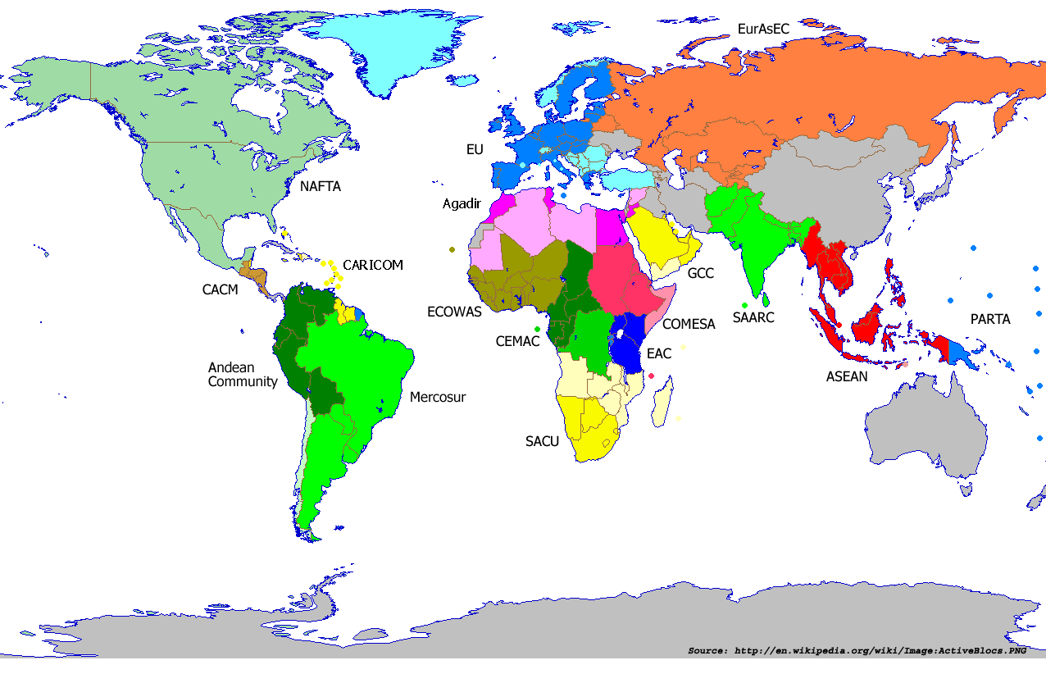

Trading relationship between MEDC / LEDC’s

Effectiveness in reducing disparities especially in the poorest areas of the world (IB case study countries)

Chapter 3 (Student: )

Debt Relief - Live 8 and Make Poverty History

What is debt relief?

Which countries are most in debt - see last hyperlink:

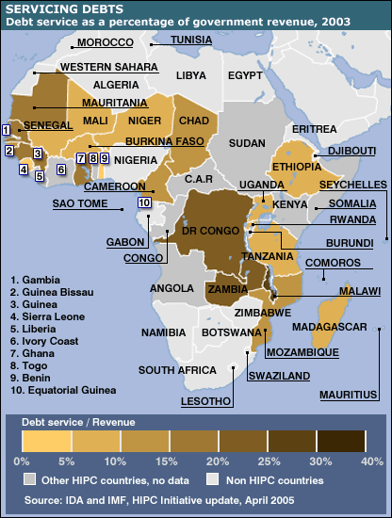

Why is LEDC debt such a problem?

How can debt reduction help to solve the disparity between countries?

What is Live8?

What was its purpose?

Who is Bob Geldof?

What was his role?

Who are the G8?

What were the outcomes of the Live8 campaign?

8 years later on in 2013, have all promises been kept?

Evaluate the effectiveness of the debt relief programme.

Chapter 4 (Student: )

Aid – Afghanistan

What is aid?
Aid is ……..

Humanitarian aid is (emergency aid is) …

Voluntary Aid is ……

Foreign Aid, is

Why has Afghanistan received aid

Is aid always used in the way that it is intended?

Evaluate the effectiveness of the Aid programme to Afghanistan

Chapter 5 – (Student )

Remittances to Africa

http://www.youtube.com/watch?v=6U8yaU01UH4
http://www.ifad.org/media/press/2009/47.htm
http://blogs.worldbank.org/africacan/how-will-the-financial-crisis-affect-remittances-to-africa
http://allafrica.com/stories/200811111001.html
http://www.imf.org/external/pubs/ft/fandd/2007/06/gupta.htm

What are remittances?

How can they help to reduce the disparities in wealth and development?

Why are remittances so important for Africa?

How much money is sent to Africa in remittances every year?

What are the problems associated with locations that the money is sent from?

How could the world recession affect the remittances to Africa and widen the disparity gap?

Evaluate the effectiveness of remittances in its ability to reduce this disparity.

