IGCSE Geography – Deforestation of the Rainforest
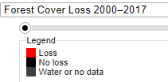
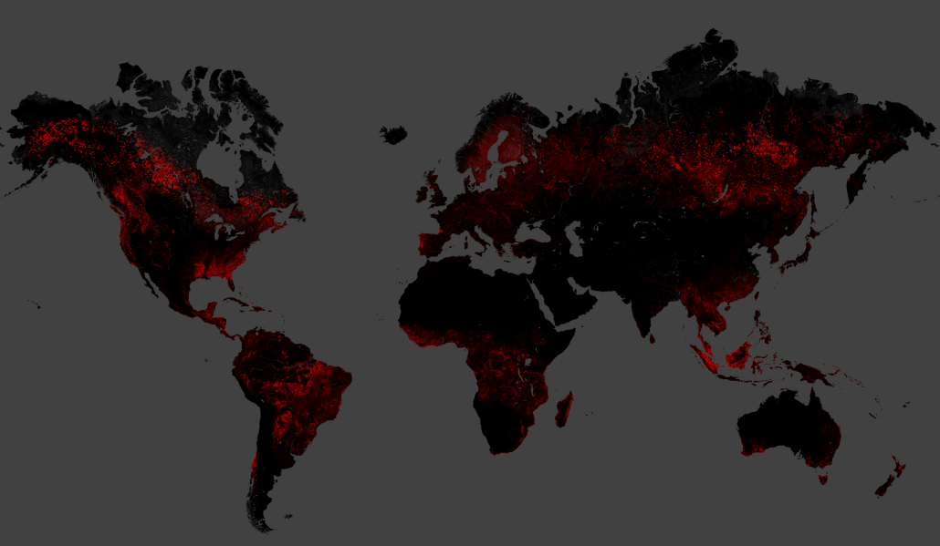
Comment on the patterns of suffered forest loss (deforestation) globally between 2000-2017. Include reference to at least two countries and possible reasons for deforestation in these places.

Is the problem of deforestation a problem associated with LICs and MICs only?

Task - What's the story in Brazil?
There have been mixed messages coming from Brazil. On one hand you have news reports like the video embedded on geographypods.

i. Watch this video and make notes on the methods using in Brazil to slow down the rate of un-managed deforestation on the left handprint.

ii. Then, read the BBC News article from November 2021 and make notes on the issues that Brazil now finds itself trying to combat (on the right handprint).

Task – 10 common rainforest products that I regularly use. Use the link on geographypods to help.
1 | 2 | 3 | 4 | 5
6 | 7 | 8 | 9 | 10

Hidden Consequences of MIC consumer use of the rainforest – watch the video embedded on geographypods and annotate at least five hidden consequences around the ‘still’ below.

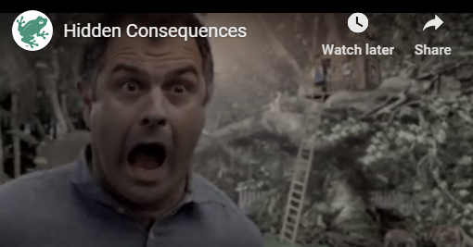

Follow the Frog! – Watch the second video embedded on geographypods and complete a piece of writing below to explain the message within the video regarding rainforest protection.

