IGCSE Geography – Deforestation of the Rainforest
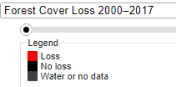
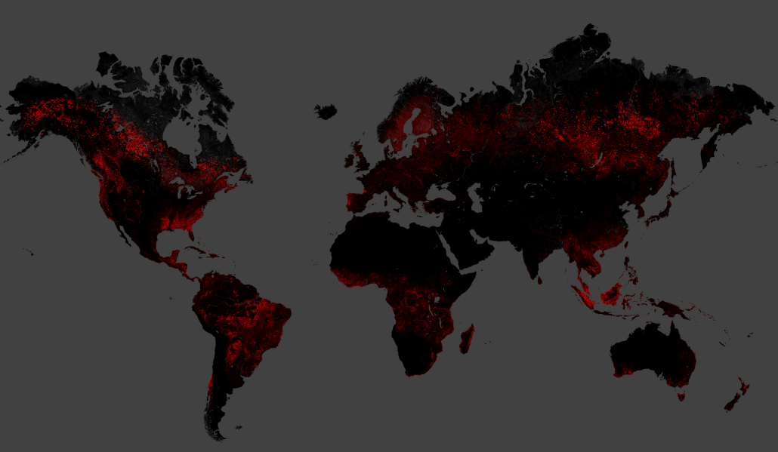
Comment on the patterns of suffered forest loss (deforestation) globally between 2000-2017. Include reference to at least two countries and possible reasons for deforestation in these places.

Is the problem of deforestation a problem associated with LEDCs and MEDCs only?

Task - What's the story in Brazil?
There have been mixed messages coming from Brazil. On one hand you have news reports like the video embedded on geographypods.

i. Watch this video and make notes on the methods using in Brazil to slow down the rate of un-managed deforestation on the left handprint.

ii. Then, read the BBC News article from November 2021 and make notes on the issues that Brazil now finds itself trying to combat (on the right handprint).

Task – 10 common rainforest products that I regularly use. Use the link on geographypods to help.
1 | 2 | 3 | 4 | 5
6 | 7 | 8 | 9 | 10

Hidden Consequences of MIC consumer use of the rainforest – watch the video embedded on geographypods and annotate at least five hidden consequences around the ‘still’ below.

Follow the Frog! – Watch the second video embedded on geographypods and complete a piece of writing below to explain the message within the video regarding rainforest protection.

Conduct your own research on Google. Fill in the table below including at least three detailed factors. I have completed the first example in each section for you.

 | …. of deforestation locally i.e. Amazonia | …. of deforestation globally
Causes | - The previous President of Brazil, Jair Bolsonaro viewed the rainforest as a resource that could be exploited to develop the Brazilian economy. | - There is global demand for rainforest timber to produce furniture and paper-based products.
Effects | - Deforestation can cause local climatic conditions to change. Given that 80% of the rainfall that falls in the rainforest comes directly from evapotranspiration from trees, this can lead to drought and desertification. | - The rainforests are known as the ‘lungs of the planet’ due to their enormous contribution to oxygen production. Continued deforestation will lead to more CO2 build up in our atmosphere.

