Protecting the Coastline – Hard & Soft Engineering Approaches

Image | How it works | Advantage | Disadvantage
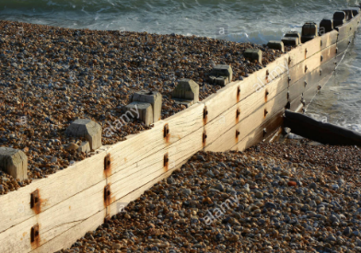 | Groyne: Wooden barrier aimed at blocking the movement of beach sediment by LSD. Traps sand on the updrift side of the groyne. | Very effective and preserved beach sediment therefore protecting tourism economy of seaside resorts. | Very costly. €230,000 per wooden groyne. Wood decays over time. May be unsightly and dangerous (Mr P story).

