Predicting Hazards– How successful are we?
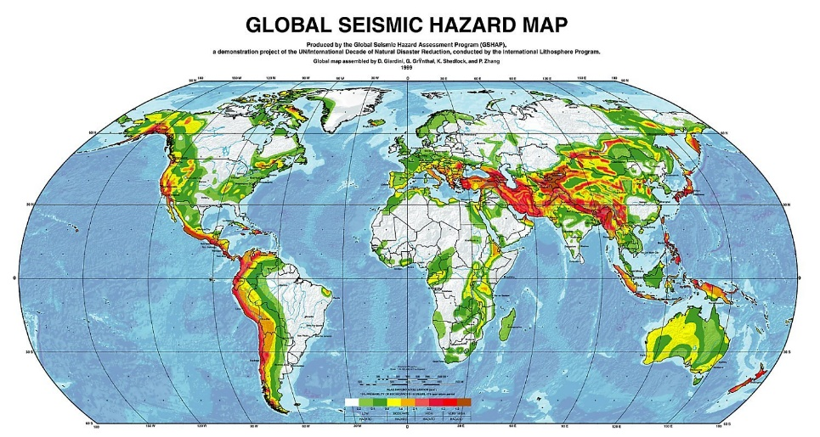
For this part of the course, you must be able to accurately describe how well we can predict two natural hazards. We will be using Earthquake and Hurricane prediction as our focus.

Task 1 – Complete the sentences below by using the words in the Key Words Box below.

Why is it important to predict hazards?

- Reduce the risk of ________ and injury.
- Reduce damage to property and ____
- To protect ___________ e.g. move cattle to higher land during a flood or cover vulnerable crops during frosts
- To give warning to citizens in order to give them time to ________ and/or prepare
- To prepare emergency services e.g. cancel non-emergency medical procedures, call up ________________ , etc.
- Cancel all non-essential travel e.g. flights and ___________ to reduce the chance of accidents
- Seek international _______________
- Give warnings to vulnerable industries e.g. recall fishing boats during __________ or close mines during ______________

When making predictions, it is necessary to look at the ______________ of an event happening, the probable magnitude of the event, the location of the hazard and its likely impact. Because all hazards contain so many variables, it is impossible to make 100% accurate predictions of hazard outcomes, but scientists are getting better.

Key Words Box

Land, assistance, hurricanes, rescue teams, probability, evacuate, flooding, shipping, agriculture, death

Earthquake Prediction & Japan
Of all the world's major natural hazards, earthquakes are probably the hardest to predict. Unlike most hazards there is no build-up of magnitude e.g. droughts and floods (they tend to get progressively worse, whereas the strongest part of the earthquake is normally the first quake), there are no warning signs e.g. volcanoes (changes in shape, heat, etc.) and the hazard does not move towards land e.g. hurricanes and even tsunamis (so you can prepare for its arrival).

Even though it is still impossible to predict the exact location, strength and time of an earthquake, seismologists have made some advances in predicting earthquakes. Below are some of the advances seismologists have used and some of the methods that they use to try and aid prediction.

- Foreshocks: An increase in the frequency of small earthquakes (foreshocks) have been used to predict large earthquakes. Probably the most famous example was the prediction of the 1975 Haicheng earthquake which measured 7.2 on the Richter scale. However, only about 5% of foreshocks lead to bigger earthquakes so there can be a lot of false alarms. (USGS - Haicheng earthquake prediction)

- Seismic History: Seismologists can study the seismic history of earthquakes and try and make predictions of when future earthquakes are likely to happen. For example El Salvador has a major earthquake roughly once every ten to twenty years. However, at best this can only give a rough time frame and can certainly not pinpoint the time or location of an earthquake.

- Animal behaviour: Some scientists believe that small animals e.g. cats, toads and dogs are able to detect pre-seismic activity and alert people to an imminent earthquake. Some scientists believe that it is low frequency electromagnetic signals that they are responding to. It is believed that toads en mass hopping across the road in Taizhou, China two days before a major earthquake that killed 10,000 people was actually a warning sign that local authorities should have acted upon.

- Plate boundaries: Most earthquakes are found along plate boundaries so scientists can alert countries and populations to the risk of earthquakes. However, even knowing the potential location certainly does not help predicting the time of a quake. Also some earthquakes happen along old and unknown plate boundaries and faults or actually happen with plate boundaries e.g. intra-plate earthquakes. Because these earthquakes are almost impossible to predict that they can cause a lot of damage because populations are not prepared.

- Radon: The release of radon has been studied as a precursor to a major earthquake. However, all studies have proved inconclusive, but what scientist claimed that he did predict the recent L'Aquila earthquake in Italy using this technique.

- Geological Changes: Scientists believe that small-scale uplift, tilt or subsidence of the ground can be precursor to major earthquakes. However, it would be almost impossible to try and monitor all geological changes around the world to try and predict earthquakes.

- Rock stress: Scientists also believe that changes in the stress of rocks can also be a sign of imminent earthquakes. Some research done along the San Andres fault suggested changes in rock stress 2 hours before an earthquake. Again though it would be almost impossible to monitor all plate boundaries look for changes in stress.

Notes on Earthquake / Tsunami Prediction in Japan 2011
Task 2 - Use the information here: http://www.geographypods.com/8-risk-and-risk-assessment.html to help you make notes on the prediction of the Japan quake and tsunami. Use the following titles to help you:

Had the earthquake been predicted?

What degree of prediction had been given?

- Methods (IT, equipment, observations)

- Locations in danger (spatial mapping, overlaying vulnerable areas to maps of settlements, oceans etc)

- Impact on life and property (planning, response)

- Accuracy (in time and space

What actions [if any] had been taken due to the predictions?

Hurricane Prediction & New Orleans
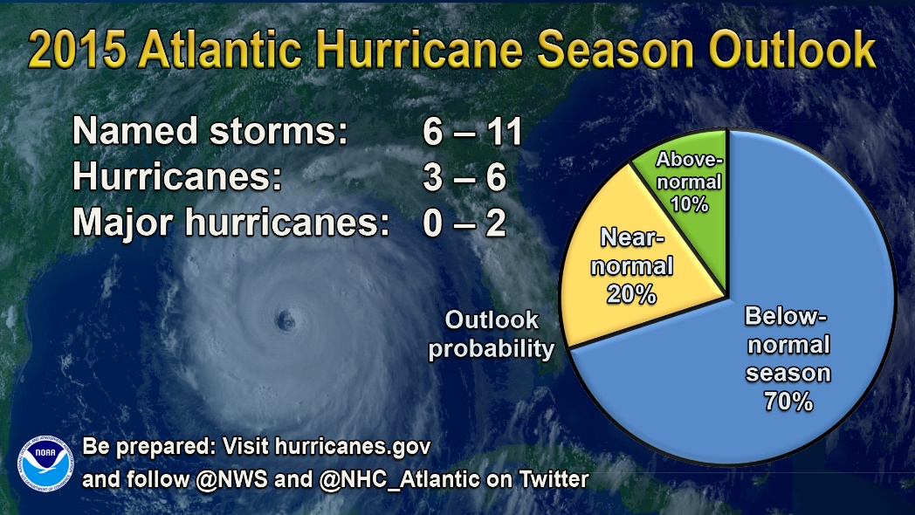

Although hurricanes are very hard to predict and track, scientists gaining a better understanding so can never give more accurate warnings. To begin with scientists know the conditions necessary for hurricanes to form, namely warm water. Therefore they know that hurricanes are likely to form in tropical areas towards the end of summer e.g. in the Caribbean between June and November. They also know that hurricanes normally move westwards (because of easterly winds) and slightly towards the poles. Even though scientists cannot say exactly when a hurricane will form, because they form at sea they can make attempts to predict the path of hurricanes so that they can predict landfall and therefore warn communities. Hurricane tracks are predicted in a number of ways, by attempting to measure; temperature (air and sea), pressure, wind speed/direction and moisture:

- Satellites: Satellites are now much more sophisticated and can measure the size of hurricanes, the direction they are travelling, but also cloud structure and ocean temperatures.

- Weather radar: The US has a total of 155 radars constantly scanning the skies over the US and its surrounds. They are capable of recording wind and precipitation data.

- Aircraft: The US Air Force uses aircraft to drop sensors into hurricanes to measure wind speed, wind direction, pressure, etc.

- Buoys and floats: These can measure water and air temperature, wave height and the direction and speed of wind.

- Computer models: All the information that is collected from the four methods above is then fed into computers to try and predict future movements and changes of hurricanes. However, even with improved data, models can often pick very varied courses and changes of hurricanes. To the right is a map showing the different computer predictions for Hurricane Katrina - you can see the predicted tracks are very varied.

Notes on Hurricane Prediction in USA 2005
Task 3 - Use the information here: http://www.geographypods.com/8-risk-and-risk-assessment.html to help you make notes on the prediction of the Japan quake and tsunami. Use the following titles to help you:

Had the hurricane been predicted?

What degree of prediction had been given?

- Methods (IT, equipment, observations)

- Locations in danger (spatial mapping, overlaying vulnerable areas to maps of settlements, oceans etc)

- Impact on life and property (planning, response)

- Accuracy (in time and space

What actions [if any] had been taken due to the predictions?

Positive:

Negative: Even with the reasonably accurate predictions many people in New Orleans chose to ignore evacuation warnings and stayed in their homes. Evacuation warning may have been ignored for many reasons including:
- Can't afford to leave (no transport)
- Fear of leaving home (possible water/wind damage and robbery)
- To old, young or ill to leave/travel
- Don't trust predictions
- Confidence in defences
- Warnings too late
- Lack of knowledge, no communication, no warning
- Underestimate risk

Why some people don’t leave the danger.
Despite improvements in predictions, evacuation warnings are not always made or made very late. Some of the reasons for the delay in evacuation notices include:

- Governments don't want to cause panic. A panic may cause more deaths than the hazard.
- The cost of ordering an evacuation (both in physically moving people and closed businesses)
- Unpredictable warnings. People may actually be evacuated into a more dangerous area.
- Late predictions. If a warning comes late it may be safer for people to stay in their homes, rather than attempting to move away.
- Some old, young and sick people are unable to travel
- Some people don't hear evacuation warnings or can't afford to evacuate (no car, nowhere to go, etc.)
- Some people don't want to leave their home, business, pets, etc. unattended
- People believe they are safe in their homes and can defend against the hazard.

Revision Corner – IB Geography 10 Mark Question
Using an example of a tectonic hazard and an example of a hurricane event, examine the effectiveness of the methods used to predict these hazards. [10 Marks]

