IB Geography – Predicting Tropical Storms
Comment on the predictability of the following features of the tropical storm hazard below by watching the YouTube video on geographypods and visiting this site.

Element | Possibility of prediction
Time that the tropical storm will make landfall | In the Atlantic Ocean, hurricane activity is tracked and recorded by the National Hurricane Center in Miami, Florida. Through complex climatic observations and charts, they are able to track the storm from formation to landfall and give a window of time (not exact) that landfall will occur together with a reasonably specific location.
Date that tropical storm will make landform
Exact location of landfall (mainland or islands)
Ocean / Sea where tropical storm will form
The magnitude of the tropical storm
The economic impact of the tropical storm | The economic impact can only be estimated if you run a simulation of different magnitude events striking particular locations with an increasing scale of damage.
The death toll from the tropical storm

Tropical Storm Frequency – Making Sense of the patterns
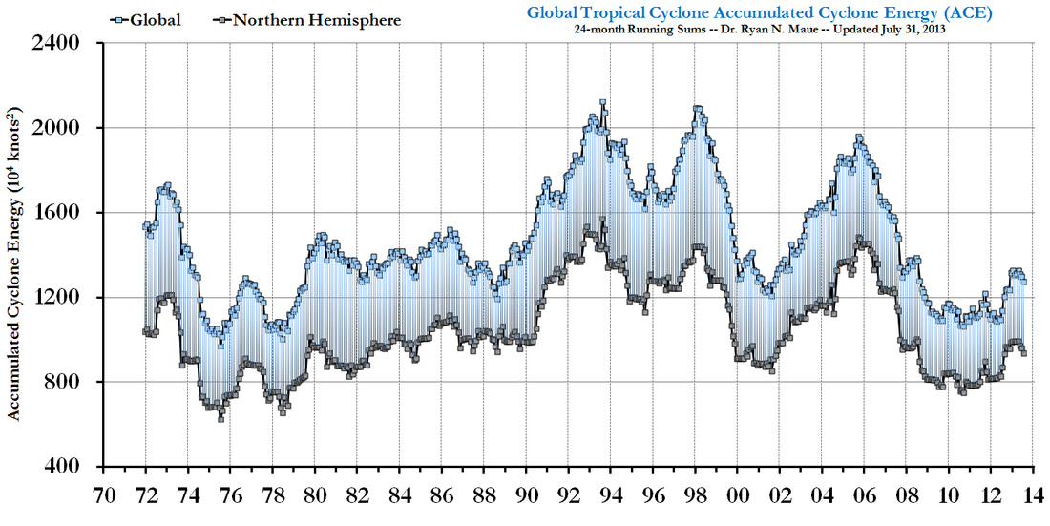

- Study the graph above and comment on the trends shown.

- Using the data, explain why the southern hemisphere has the potential for more powerful tropical storms that the northern hemisphere.

Note: Tropical Storms happen in vulnerable countries every year at certain times (hurricane seasons). Unlike earthquakes and droughts, they follow a clear seasonal pattern. Turn over to study the patterns of tropical storm activity in a typical season.

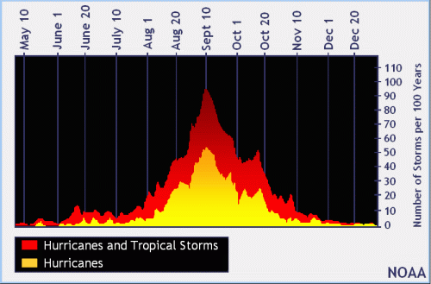

a. How long does the tropical storm season last for?

b. Which time period sees the most hurricane activity?

c. Describe the trend of hurricane events during a typical storm season

d. Explain the trend in the graph above.

