IGCSE Coasts – Power of the Ocean Waves
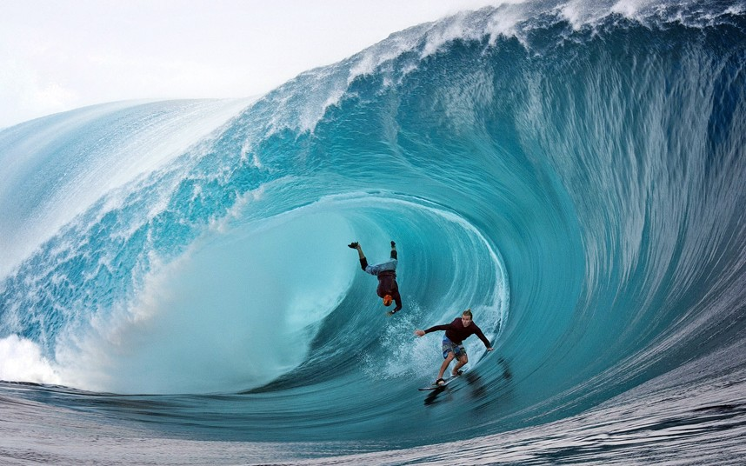

Objective: To find out how waves shape the coastline.
The coast is the name given to the zone where the land meets the sea/ocean. Coasts are shaped by the sea and the action of waves. The processes that take place are erosion, transportation and deposition.
The action of waves
The power of waves is one of the most significant forces of coastal change. Waves are created by wind blowing over the surface of the sea. As the wind blows over the sea, friction is created - producing a swell in the water. The energy of the wind causes water particles to rotate inside the swell and this moves the wave forward.
The size and energy of a wave is influenced by:
1
2
3

Diagram of wave formation from geographypods
Task 3 - Mix & Match - Match the correct keyword to definition from the list underneath. Use your highlighter pen on each key word as they are really important for your exam.

Crest:  Backwash:  Velocity:  Wavelength:  Trough:  Wave height:  Swash:  Wave Frequency: | The top of the wave.  The low area in between two waves.  The distance between two crests or two troughs.  The distance between the crest and the trough.  The number of waves per minute.  The speed that a wave is traveling. It is influenced by the wind,  fetch and depth of water.  The movement of water and load up the beach.  The movement of water and load back down the beach.

