Name

IGCSE Geography - Population Pyramids & Stages of Development
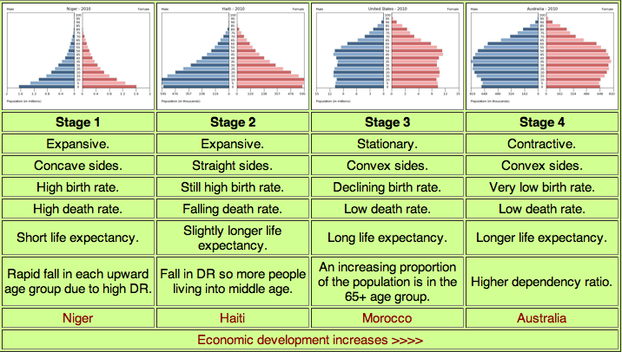
Describe & explain how the population pyramid shape changes as you move through different levels of development.

http://www.geographypods.com/2-population-change.html

