Population Momentum – IB Geography
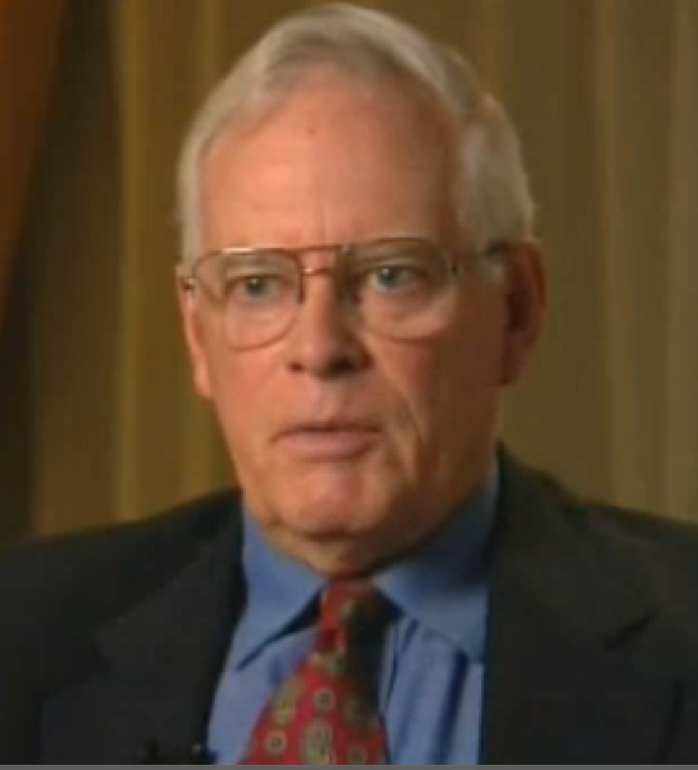
What does population momentum refer to? What does Dr Tanton say?

“Lots of people will make lots of babies”

