G7 – Everest 1953 – Planning My Fakebook Diary
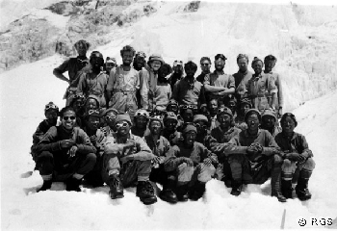
Task 1 – As we are reading through the factsheet, fill in your key people below.
Key Person 1 | Key Person 2 | Key Person 3
Key Person 4 | Key Person 5 | Key Person 6

Task 2 – In the space below, make notes of key dates and what happened on those dates from arriving in Nepal to reaching the summit of Everest.
Date | Event

Fakebook Profile Written in the name of
Friends (up to six)
Number of status updates
Other information

