IGCSE - Physical & Human Factors Influencing Population Density
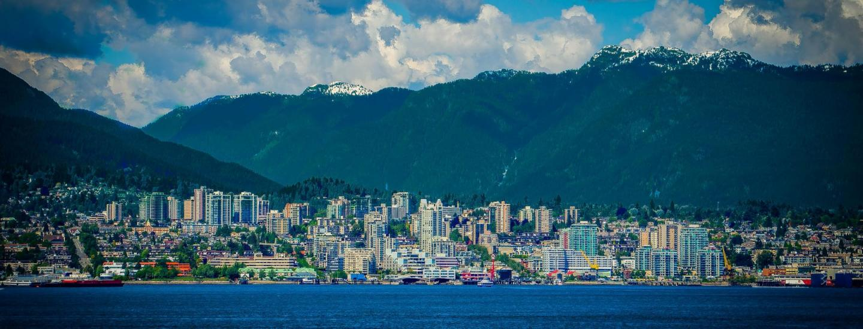
Task 1 - Complete the blank spaces below by choosing from the correct sentences in the key word box on the next page.
Physical Factors | High Density | Low Density
Relief (shape & height of land)

Resources

Climate

Human Factors | High Density | Low Density
Political

Social

Economic

Other groups of people who might prefer to be isolated e.g. Siberia. | High land that is mountainous e.g. Himalayas | Areas with extreme climates of hot and cold tend to be sparsely populated e.g. the Sahara Desert
Unstable countries tend to have lower population densities as people migrate e.g. Afghanistan. | Areas with few resources tend to be sparsely populated e.g. The Gobi desert | Groups of people want to live close to each other for security e.g. east coast of the USA.
Low land which is flat e.g. Ganges Valley in India | Countries with stable governments tend to have a high population density e.g. Singapore | Good job opportunities encourage high population densities, particularly in large cities in MEDCs and LEDCs around the world e.g. Sydney.
Areas with temperate climates tend to be densely populated as there is enough rain and heat to grow crops e.g. France | Limited job opportunities cause some areas to be sparsely populated e.g. Amazon Rainforest | Areas rich in resources (e.g. coal, oil, wood, fishing etc.) tend to densely populated e.g. east coast of China.

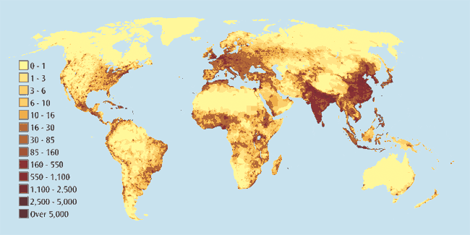

Task 2 - There were several places mentioned in the activity above. Add a number to each information box in the table above. Please locate the 12 places mentioned on the map above and add either a small text text box and arrow to show the number or annotate on with your laptop pen.

Many thanks to ‘Internet Geography’ for the inspiration for this activity.

