IB Geography - Globalization – A Perfect Example?
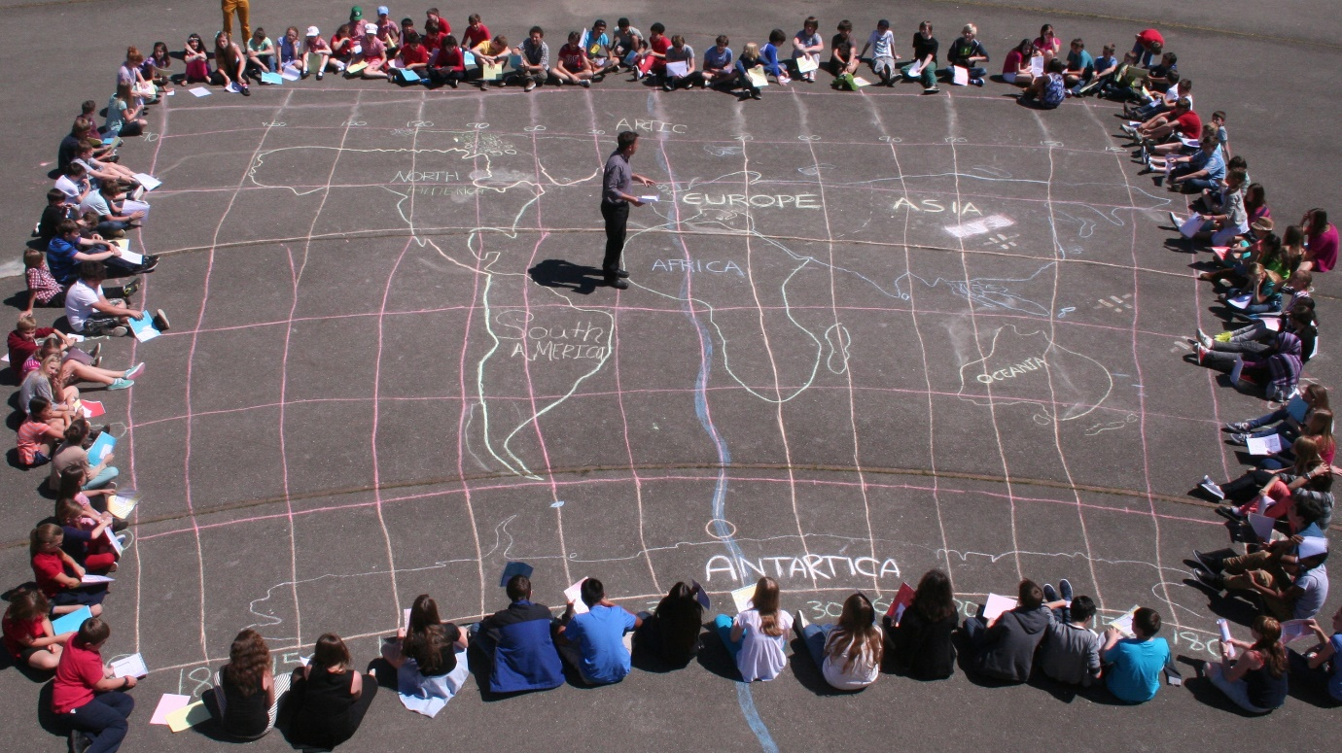
"Globalization is the growing interdependence of countries worldwide through an increasing volume and variety of cross-border transactions in goods and services and of international capital flows, and through the more widespread diffusion of technology"
Task 1 – Can you think of the perfect product of service that encapsulates each element of the definition above?

countries become interdependent  Product or service image here | increasing what they buy and sell with each other
resulting in the flow of money (capital) between places | and the sharing and take up of technology in those countries

Task 2 – Say hello to Year 12 IB Students. Shade in on the map the locations of where your hello Tweets come from in the world.

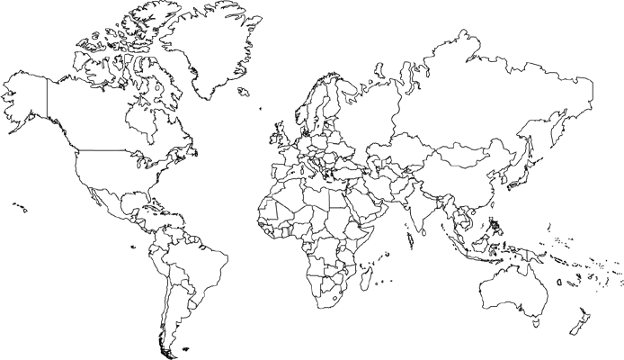

Total Stats after 60 mins.

