Peak Oil – Geopolitical Impacts of Oil Production
Notes: Oil Production has peaked.
IB Geography March 2013
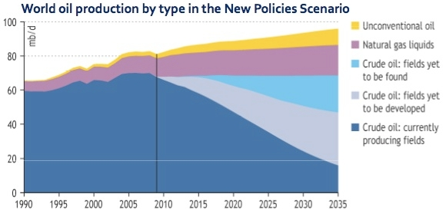

- According to this graph, what year was peak Crude Oil extraction reached?

- Describe the best case scenario for the continued use of Crude Oil between now and 2035

- Click here to be taken to an article about crude oil fields yet to be developed? To what
extent does this location prove to be controversial in terms of potential future oil extraction?

Hubbert’s Peak Graph
Video Notes Continued

