**Over the Horizon**

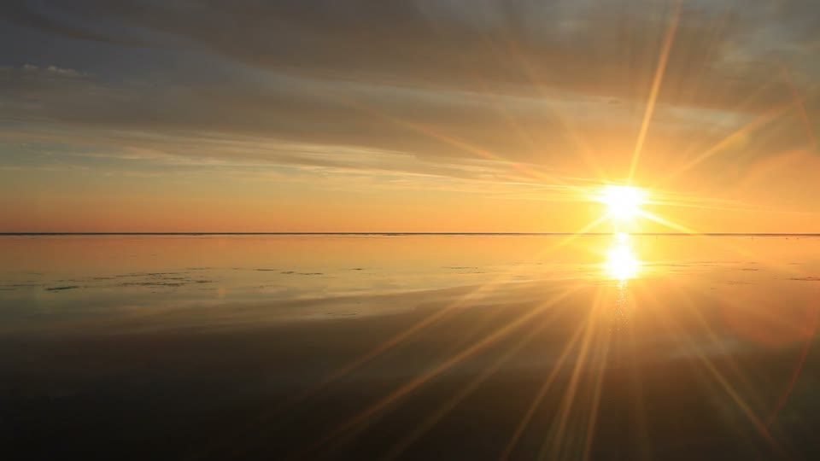**(and far, far away).**

**Source: EYDT**

**Geography**

**Name __________________________________ Year Group _________**

**School Visible Horizon (0.175km)**

Look again at the image on the front cover of this work booklet. Many of us have sat on a beach and enjoyed a fine view like this.

***When looking at a sea from a shore, the part of the sea closest to the horizon is called the offing. The word horizon derives from the Greek horizōn kyklos, "separating circle" and from the verb horizō, "to divide", "to separate". (Wikipedia 2018).***

Sadly, we do not have a sea view here in Toulouse. Our view is shown below.

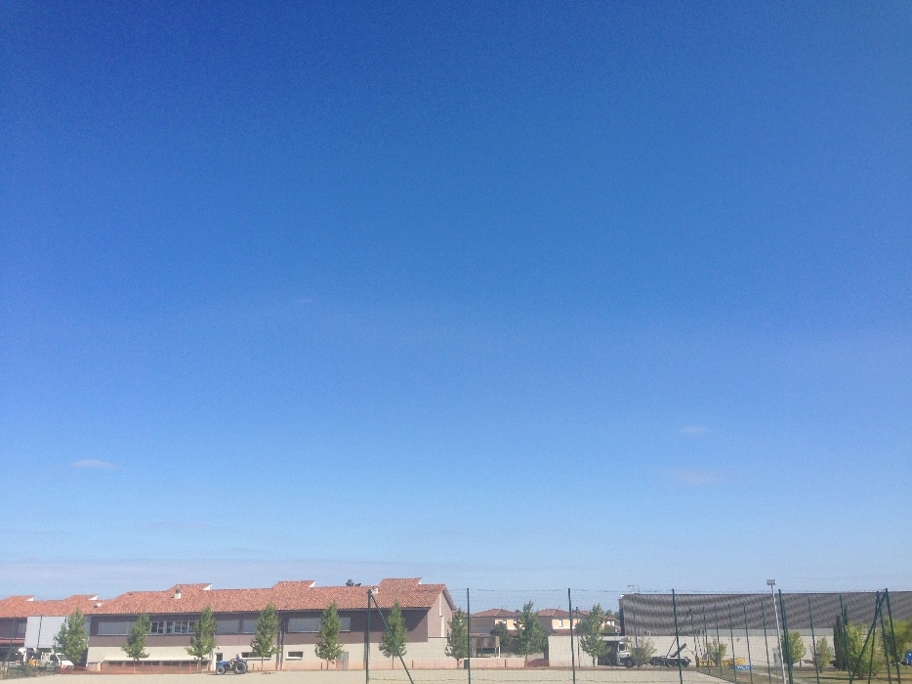

**Task 1**. Study the photo above carefully (also on geographypods). It was taken at 11am on Friday 31st August 2018. Now, look out of the window of EC7 30 and note three differences that you see in the table beneath.

|  |  |
| --- | --- |
| What was there then - 31st August | What has changed today? |
| 1  2  3 |  |

**Task 2**. Our horizon is obscured by buildings. Looking directly out of the window at the same view as the photo on the website, the furthest thing we can see (where the land or the buildings meet the sky) is approximately 175 metres away. Label the furthest visible horizon on the photo on the previous page.

**Task 3**. The photo below was taken from another school Geography classroom.

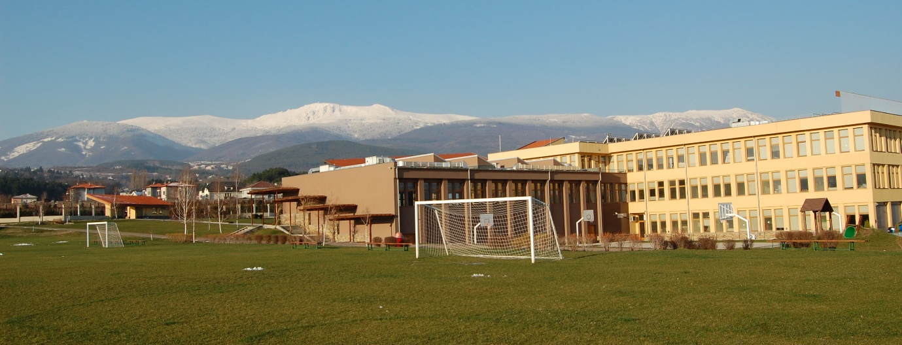

What can you see in this image? Write a short description below.

What is the furthest point you can see on the photo? How far away do you think it could be? How long would it take to walk there?

Where in the world do you think this photo was taken. Why do you think that & what are the clues?

**Far Away (29,000km).**

You have probably heard that for a long time, many people though that the Earth was flat. They thought that it was flat because unless you had a full horizon view and were very observant, you could not see the curvature of the planet. For most of human history, up until 1948 no photos had been taken of Earth from Space. The first photo showing Planet Earth ***in its entirety*** (and therefore that it was indeed a sphere) was taken on December 7, 1972, by the crew of the Apollo 17 spacecraft at a distance of about **29,000 km**. The photo has become known as the ‘Blue Marble’.

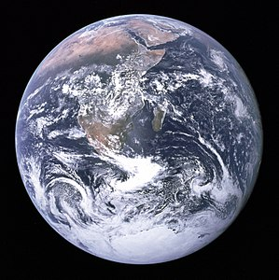

Source: NASA

**Task 4** – Study the Blue Marble image above. Now scroll down to the live video of Earth from Space from the International Space Station. You will need your headphones on to get the full effect! In the space below, write down 10 adjectives that describe the feelings of the crew of Apollo 17 as they saw Earth in its entirety for the first time.

1 6

2 7

3 8

4 9

5 10

**Far, Far Away (6,000,000,000 km)!**

*Dark grey and black static with coloured vertical rays of sunlight over part of the image. A small pale blue point of light is barely visible.*

*Seen from about 6 billion kilometers, Earth appears as a tiny dot (the blueish-white speck approximately halfway down the brown band to the right) within the darkness of deep space.*

*Pale Blue Dot is a photograph of planet Earth taken on February 14, 1990, by the Voyager 1 space probe from a record distance of about* ***6 billion kilometers***

*In 2018, the spacecraft still travelling at 64,000 km/h (40,000 mph), is the most distant man-made object from Earth and the first one to leave the Solar System. (Wikipedia 2018)*

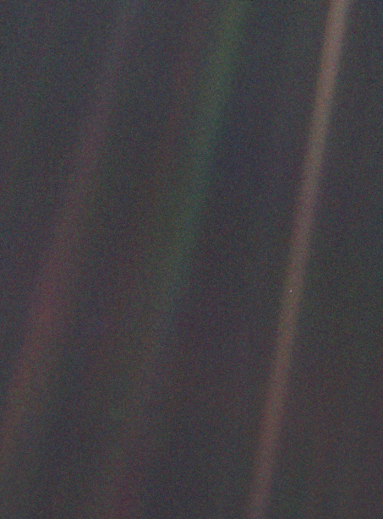

Us !

**Task 5 – The Pale Blue Dot**

Watch the Pale Blue Dot video embedded on Geographypods with your headphones on. Do not stop the video.

Now watch the video again, pressing pause and giving yourself time to reflect. Try to fill in one example for each of a selection of people mentioned in the video.

|  |  |  |  |
| --- | --- | --- | --- |
| Your Home Town | Two people you love! | An event of joy | An event of suffering |
|  |  |  |  |
| An example of a religion | A hero | A coward | Creator of a civilisation |
|  |  |  |  |
| Destroyer of a civilisation | A King | Inventor and what they invented | Explorer and where they explored |
|  |  |  |  |
| Corrupt Politician | A superstar | A ‘supreme’ leader | A saint ☺ |
|  |  |  |  |
| A sinner ☹ | My hero | **“….. all lived on this mote of dust, suspended in a sun beam!”** | |
|  |  |

**Over the Horizon … and back!**

Remember the first photo on geographypods? The view from your Geography classroom window. You can see it right now by standing up and having a good look out. **We are facing North**.

* What actually lies beyond the Geography classroom horizon?
* What if we set out on an adventure?
* An adventure following a longitude line from our Geography window
* Out beyond the houses behind the Primary School and leaving the town.
* Keeping to that line and eventually arriving back in the Geography classroom.

If we did that, we would travel a total of 40,075 km. Following our longitude line, over land, sea, mountain ranges, ice caps, deserts, the equator (twice!) and great oceans. We would eventually arrive back in our classroom!

Check out one of the globes on the table. Find Toulouse and head north, up and over the North Pole, down the other side, over the equator until you reach the South Pole and then back up, over the Equator and back to Toulouse. Got the idea?

**Task 6**. Watch the video entitled ‘Following Our Horizon 1’ on geographypods. This is a silent video and before you start, you need to watch out for a few things:

1. The vertical (longitude) yellow line is 0° it is where time starts.
2. Colomiers is located 1.3° to the east of this line (so a little bit to the right of this yellow line!).
3. You will recognise the countries that we pass through as we head north from Colomiers & France.
4. However, as we cross the North Pole and head south, the countries are all upside down!
5. Once we reach the South Pole we then start heading back up and the map and shapes of the countries look familiar again.

So, all of that looks normal if you look at it on a globe, but what about if you tried to show the route on a flat map like on the wall of the classroom.

Turn over to see what the same route looks like!

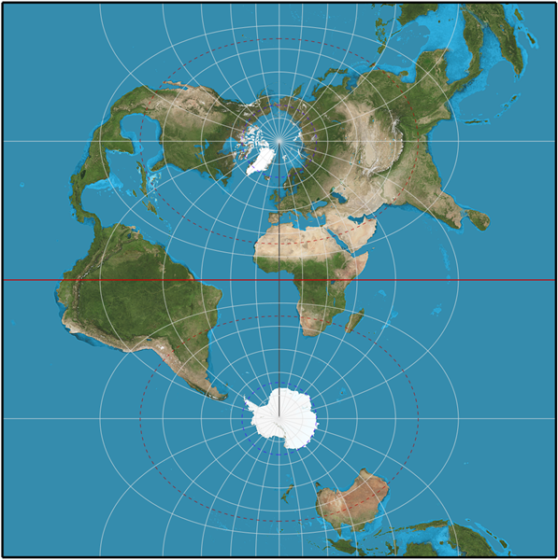**What is Over the Horizon? - Information Sheet – Geography**

Step 1 - Leave Colomiers heading North

Step 2 Just crossed the North Pole

Step 3 – The World isn’t flat you know so jump to the bottom of the map !

Step 8 – Back to Colomiers after 40,075km!

Step 7 – just crossed the equator again…

Step 6 – Over the South Pole and heading north again

Step 5 – you will spot Australia & New Zealand upside down!

Step 4 – just crossed the equator and heading south

Start at step 1 (right hand side) and work your way through to Step 8 (left hand side). This map shows the world cut in half (like an orange), then placed flat side down, one above the other.

So, as you can see, this is the easiest way to show the horizon route on a map but it isn’t a map of the world that looks like the one that you are used to.

What happens when we try to plot the route on a Google Map or like the map on your classroom wall? Turn over to see an awful effort by Mr Podbury!

So, your over the horizon journey is OK until you get to the North Pole, then goes crazy until it gets to the South Pole, then follows a nice straight line again!

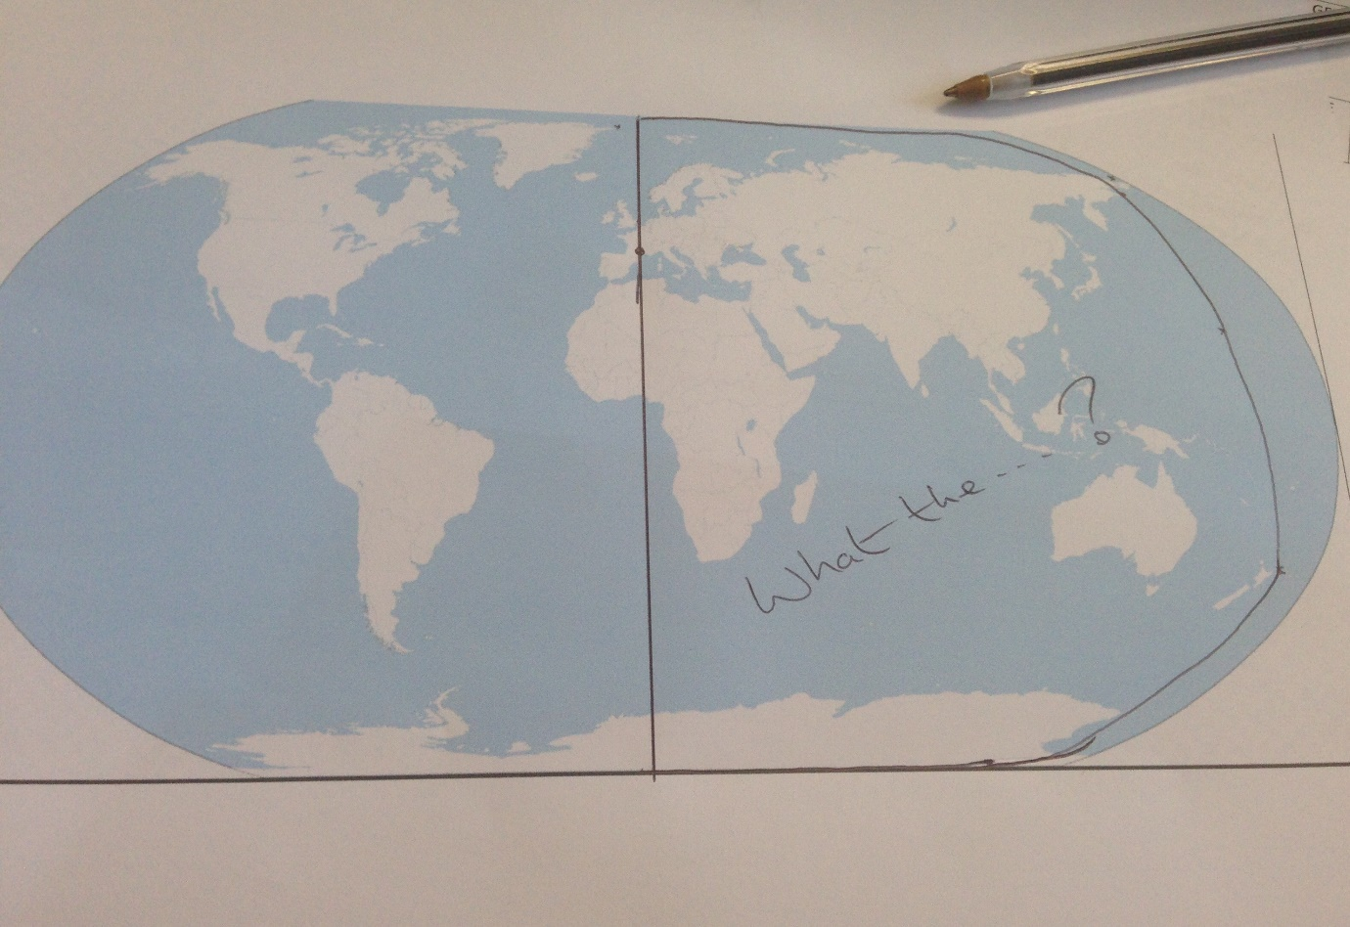

**Task 7.** In the space below, explain why the journey looks so distorted on this flat and traditional map of the world.

**Task 8** – So now that you know that the globe is best (& easiest) for tracking journeys of longitude (vertical lines), you are going to start to put together your ‘Over The Horizon Project’. To help, you will need to use Google Earth / Google Maps or the Atlases on the shelf in EC7 30.

**Instructions:**

1. Create a presentation - ‘My Journey Over the Horizon’

You should ensure that you research the places that you may cross on your voyage around the globe.

You can use the following framework and include at least three places / factors from each category in your finished work.

|  |  |
| --- | --- |
| **Countries Crossed** | **Oceans & Seas Crossed** |
| France  Russia  Transport: | North Sea  Transport: |
| **Small islands Crossed or passed by** | **Frozen Places Crossed** |
| Wrangel  Fiji  Transport: | Ross Ice Shelf  Transport: |
| **Hot Places Crossed** | **Dangers Faced** |
| Transport: | Hypothermia |

You may complete your diary on the computer or on paper. If you are using your computer, you can use one of the following applications to record your adventure:

* Word
* PowerPoint
* Publisher
* Google Earth Tour (only for those who know how to do this).
* Movie Maker – with recorded narration.

If you wish to work on paper, there are ample supplies of paper and display card in the bottom drawers of the map chest in EC7 30. Glue and scissors are in the cupboards in the classroom.

**Remember:** You are travelling following the same line of latitude. If you left our classroom facing the horizon, these are the real places that you would visit to on your journey around the world. 40,075km to go by foot, boat and snow mobile! Allez.

Note: This is individual work. Group or paired work not permitted.

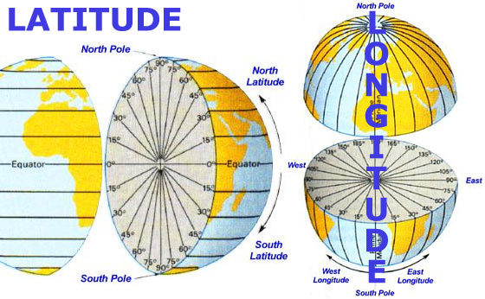

Notes and possible resources to use: