Out of Town Shopping Centres – The Good & The Bad
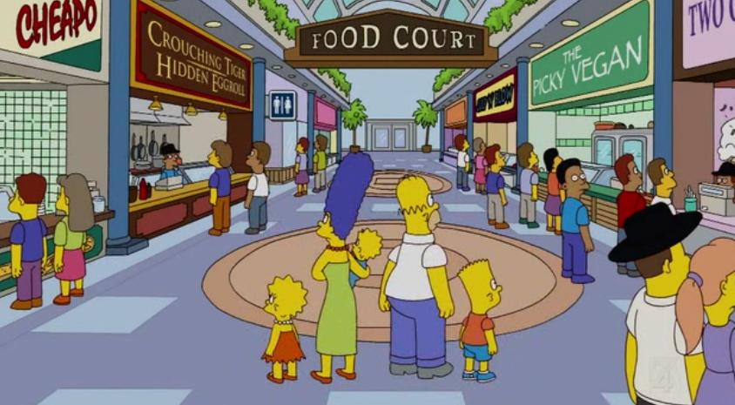
The advantages | The disadvantages

The distribution of shopping centres around Toulouse

