Year 9 – IST

Development Proposal

Name ________________ Group ____

Year 9 Niagara Redeveloped – Spotting Your Niche (gap)
Task 1 – All good businesses should be able to spot a niche (gap) in the market and be able and prepared to exploit it to gain new customers and boost business overall.

Your first task is to think about Niagara. What three things would you say would improve the tourism experience in the area? Explain why each would be a benefit
Improvement 1 -

Improvement 2 -

Improvement 3 -

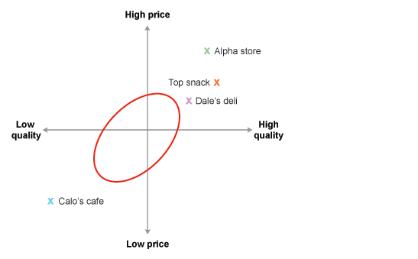
Another tool used to help identify a business opportunity is a market map. A market map is a diagram that identifies all the products in the market using two key features.
The diagram shows how four local cafés are competing in terms of price and quality.
The red circle identifies a gap in the market. There is a business opportunity for a new café offering standard quality products at standard prices

Creating Your Sustainable Niagara Brand Identity
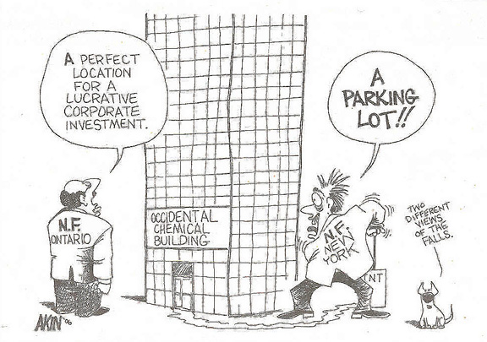
Brand identity is an important part of marketing. It says something about your business or its physical products; for example, what they look like, how they smell or feel. In fact, properly created, a brand identity says everything about what the product wants to be.

Your task will be to redevelop and rebrand a chosen area of Niagara.

You must now try to create your own brand identity by working on the following tasks.

Task 2 - Your Logo – Every brand has a logo. McDonalds has the ‘Golden Arches’, Nike has the tick and Apple has, well …….. an apple! Your aim is to be more sustainable (SEE). How can your brand conjure up those key elements of social, economic & environmental sustainability?
Socially ……

Economically …….

Environmentally …..

Task 3 - Your Logo - You must now come up with a rough sketch of your logo to match your brand identity. Sketch this into the space below.
First attempt | Attempt after Task 4

Task 4 – Share this design with your team. Does it work? Note any improvements suggested in the space below.

Task 5 – All successful brands have a slogan. Nike has ‘just do it’, McDonalds has ‘I’m lovin’ it’ etc. What is yours going to be? Come up with three in the space below.
1

2

3

Thinking about your Niagara ‘Market Segment’.
Most markets contain different groups of customers who share similar characteristics and buying habits. These collections of similar buyers make up distinct market segments.

Think about your market segments in Niagara. The following are the four basic categories of tourism:

- Beach holidays, eg in Spain and the Maldives. People can relax on the beach or take part in water sports.

- Outdoor adventure, eg skiing and walking in the European Alps or the Rocky Mountains of North America.

- Cultural/historic, eg people like to visit historic sites, art galleries and museums in cities such as Rome and Paris. In cities like New York and London they can go shopping or see shows.

- Ecotourism, eg small numbers of people go trekking in the Amazon rainforest or on whale and dolphin conservation holidays in Scotland. This type of tourism is designed to be sustainable.

Task 6 – Choose one of the types of tourism above and explain how you could develop tourism in Niagara to exploit a particular market segment.

Task 7 – Choose a second type of tourism above and explain how you could develop tourism in Niagara to exploit a particular market segment.

Task 8 – Choose a third type of tourism above and explain how you could develop tourism in Niagara to exploit a particular market segment.

Task 9 – As a group, please decide which market segment you are going to exploit in terms of the type of tourism you will develop. Explain why.

Choosing Your Area – Niagara Redeveloped

Task 12 – On the image below, identify an area that you would like to consider for your sustainable tourism redevelopment plan. Keep is reasonably small in scale and think carefully about SEE sustainability.

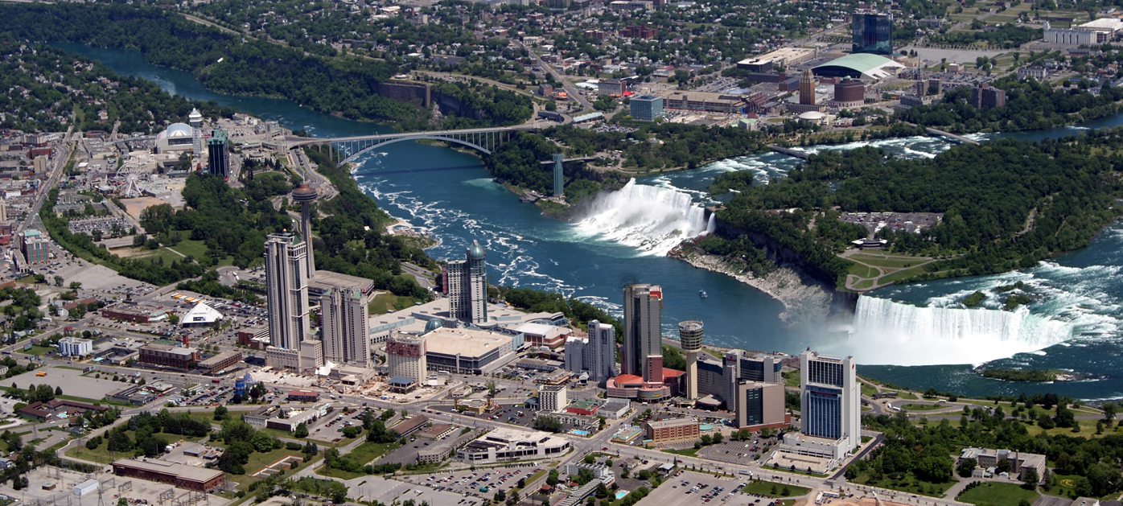

Niagara Re-developed

Your brief: You have been recruited by Niagara Sustainable Solutions LTD to put together a marketing campaign to try to boost sustainable tourism in the vicinity of the Falls. This campaign will be presented officially in front of the Council.

- Your plan should be presented on A2 paper and should represent an architect’s plan. The following must be present
- Area to be developed (worksheet here)

- Arial plan version of the site showing the features.

- Sketch of buildings showing features and materials.

- List of activities for tourists linking to sustainability (checklist and notes sheet is here).

- Written report of 500 words to the Niagara Falls Tourist board recommending why your plan is better than the rest (of the class).

- The mark scheme can be accessed on geographypods

