National Olympic and Paralympic Venues for ‘London 2012’
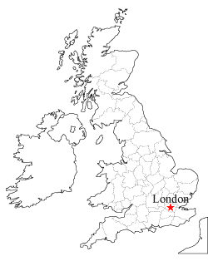

Greater London Olympic and Paralympic Venues for ‘London 2012’

