G6 – Otzi The Iceman – Investigation Starter
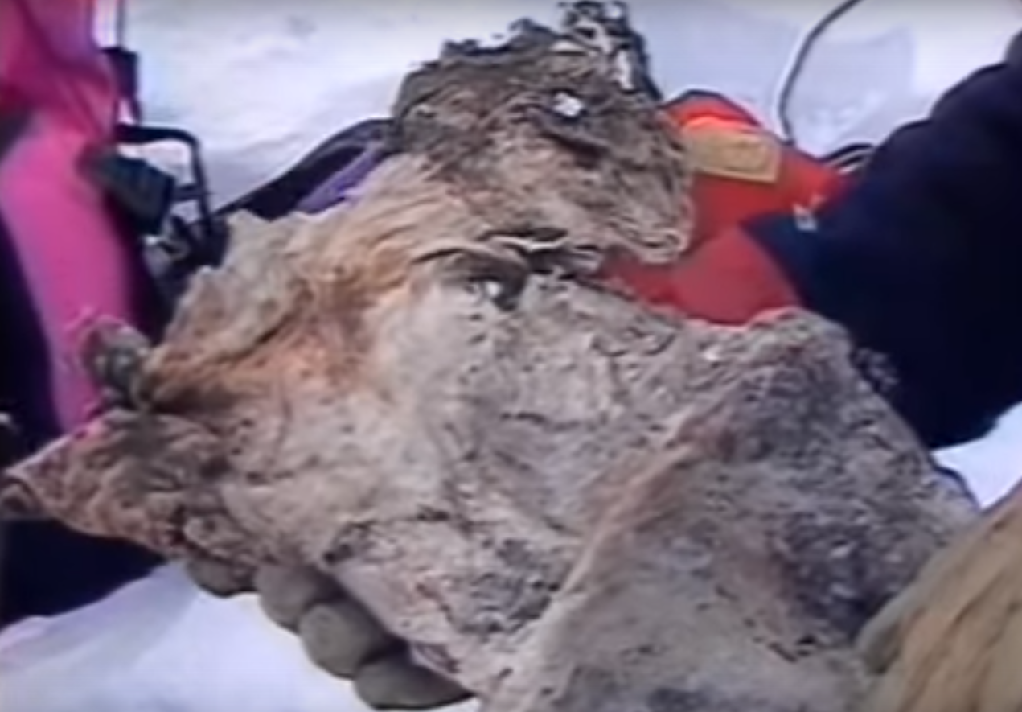

Geography Invesitgators – Please study the image above and tell us what you think this object is? Look for as many clues as possible and don’t discuss it with anyone.

