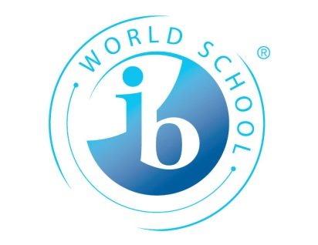
IB Geography
Year 12 Mock Examination – Tuesday 24 April PM
How is the paper structured?
As we are only just half way through the course, this exam will be fairly specific to the sections that you have studied so far i.e. Populations in Transition (HL&SL), Sports, Leisure & Tourism (HL&SL) and an additional question on Global Interactions for the HL students.
SL students, there are two sections to the paper – Populations in Transition (60 mins) and Sports Leisure Tourism (40 mins). Total 1hr40
HL Students, there are three sections to your paper. The same as for SL and an additional 10 mark essay question on Global Interactions (20 mins). Total 2hrs
Focus your revision
Core Patterns & Change - Paper 1 – 60 minutes –(Two structured questions & one essay question)
So far we have covered the following subunits:
Unit | Revision Recommended
Population Change | Yes
High & Low Fertility | Yes
Migration | Yes
Gender & Change | Yes

Can you?
- Interpret a population pyramid and explain the four different stages?
- Define fertility rates, crude death rates, crude birth rates, life expectancy, ageing ratios, population momentum, literacy rates, Human Development Index, GDP, GNI and population projections?
- Remember your case study on youthful and ageing populations?
- Remember the key aspects of the Girl Effect and areas of the world where gender imbalances exist (MEDC & LEDC)? Remember the acting?
- Give full details of both the pro and anti Natalist policies in the case study countries? Can you remember your facts and figures, key dates and reasons for implementation?
- Fully explain internal and external migrations and remember the case study examples? What are the SEEP positives and negatives to both place of origin and destination?

Please turn over for futher guidance:

Optional Unit E - Sports, Leisure & Tourism Paper 2 – 40 minutes (Choice: One of two questions)
We have fully completed this optional unit.
Sub unit | Revision
1. Leisure - Definitions | Yes
2. Leisure at the international scale: tourism | Brush up
3. Leisure at the international scale: sport | Yes
4. Leisure at the national/regional scale: tourism | Yes
5. Leisure at the national/regional scale: sport | Brush up
6. Leisure at the local scale: tourism | Brush up
7. Leisure at the local scale: sport and recreation | Brush up
8. Sustainable tourism | Yes
Check out www.geographypods.com for full listings of lesson content.
Can You?
- Analyse the social, cultural, economic and political factors affecting participation and success in two major international sports (Grand Prix and Premier League Football)?
- Analyse the geographic factors that influenced the choice of venue(s) for World Cup 2010 South Africa?
- Examine the factors affecting the sphere of influence for participants and supporters in the World Cup?
- Evaluate the short and long-term geographic costs and benefits of hosting such an event at both the local and national level?
- Define sustainable tourism?
- Examine the extent to which it may be successfully implemented in different environments?
- Examine the economic, social and environmental impacts of tourism on different case study countries?
- Assess the importance of tourism as a development strategy for low-income countries?
Higher Level Interactions – Paper 3 – 20 minutes – Essay type question (Choose one of two questions)
Sub Unit | Revision
Measuring Global Interactions | Yes
Changing Space – The Shrinking World | Brush up
Economic Interactions and Flows | Yes
Can you?
- Define the KOF Index and explain how it is calculated?
- Distinguish between global core and peripheries in terms of the flow of information, ideas and finance?
- Examine the importance of loans, debt repayment and remittances in the transfer of capital between the developed core areas and the peripheries?
- Explain the growth and impact of international outsourcing?
Stuck? – Email or better still, use the Facebook group page to ask questions. Also, don’t forget to use your IB Revision Guides. There are sample questions and mark schemes to help you out.

