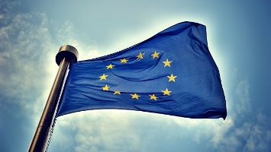**The #Refugeecrisis in the EU**

**Does the press represent the crisis accurately?**

